Year 5 Home Learning (Topic) WC 15th June 2020
Dear Year 5,
This week, we will be celebrating ‘Refugee Week’ - a UK-wide festival celebrating the contributions, creativity and resilience of refugees. Founded in 1998 and held every year around ‘World Refugee Day’ on the 20th June, Refugee Week is also a growing global movement. Some of our home learning will therefore be linked to this.
Here are the tasks for this week:
1) Refugee Week
Read the information, watch the video and complete the activities from the Kazzum Arts,
Refugee Week, Primary School Resource Pack.

You can share any work you have completed by emailing this/a photo of your work to: y5@williamdavis.org.uk
We are always excited to see pupils’ home learning!
2) Geography revision
This week’s revision will be linked to our previous topic of ‘My London’ and the learning we completed about
different types of settlements. Your tasks are, like last week, set on the Seneca Learning platform.

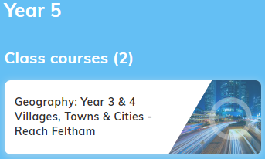
Just a reminder how to access your Seneca class:
The easiest way to access your class work is by copying/typing this link into your browser:
https://app.senecalearning.com/dashboard/join-class/ylngdrrzos
This will take you straight to your assigned tasks. Alternatively, you can follow the instructions below:
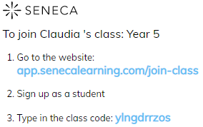

Please contact me via the Year 5 email above, or by calling the school, if you have any problems.
Have a good week!
Claudia

