Year 3 LITERACY week beginning 11.5.2020
This week you will be creating some Stone Age characters and writing and drawing some conversations between the characters.
Monday 11th May 2020 LI: To answer questions about a book
Read the first page of the book ‘Ug the Stone Age Boy’ by Raymond Briggs and answer the questions below.

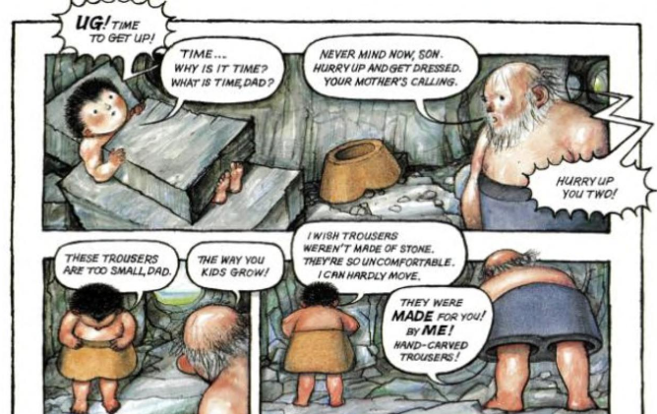
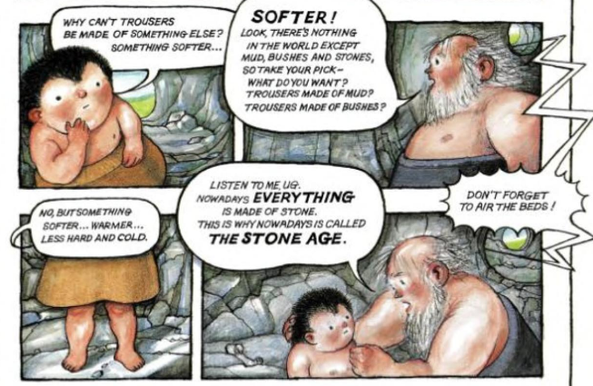

- The little boy is called Ug. What do you notice about Ug’s bed?

- What are Ug’s trousers made from?

- What does Ug think about his trousers? Why?

- Why do you think Dad Ug’s Dad seems cross when Ug complains about his trousers?

- Ug is a humorous, funny book in a cartoon style. Are there any parts so far that you like or that make you laugh?

- What questions fo you have about this book so far?
I wonder… who, what, why, where, when, how?

- What do you predict will happen next in the story?

Monday 11th May 2020: Spelling & handwriting
Complete the handwriting sheet below:
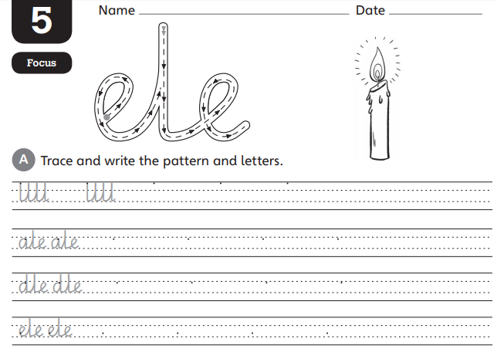
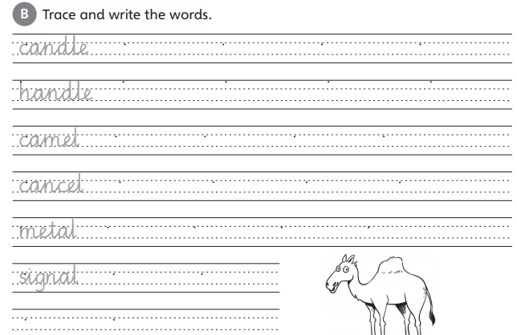

Tuesday 12th May 2020 LI: To find facts about characters
Re-read the first page of Ug.
Create a Role on the Wall for Ug and Ug’s Dad.
Write facts that we know about the characters on the outside.
Write words and sentences to describe their personality, thoughts and feelings on the inside.

Ug  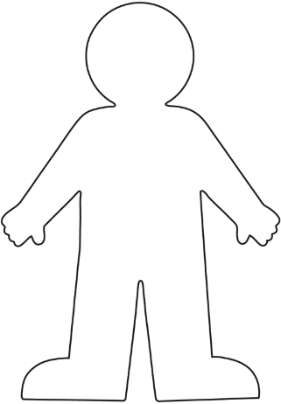 | Ug’s Dad
Tuesday 12th May 2020: Spelling & handwriting
Complete the handwriting sheet below:
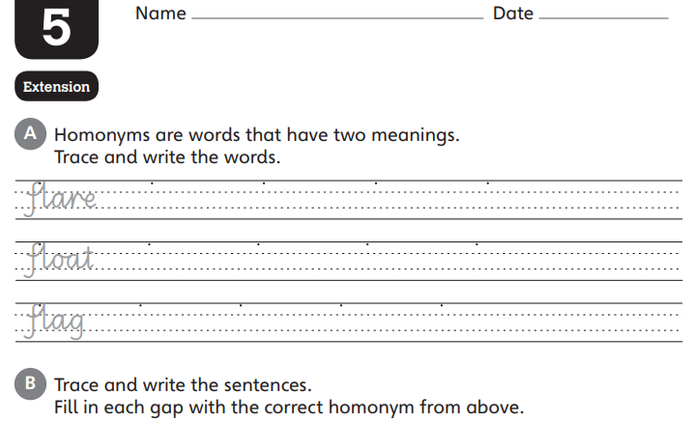

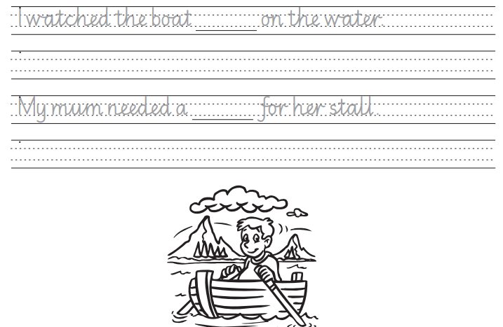

Wednesday 13th May 2020 LI: To invent some Stone Age characters
Invent two Stone Age characters of your own. Maybe they are also father and son, or mother and daughter. Maybe they are brother and sister or two best friends.
Draw and write about your two characters below.
Name:____________________  What are they good at?_______  _________________________  _________________________  _________________________  What kind of person are they?  (funny? kind? helpful? brave?)  _________________________  _________________________  _________________________ | Name:_____________________  What are they good at?_______  _________________________  _________________________  _________________________  What kind of person are they?  (funny? kind? helpful? brave?)  _________________________  _________________________  _________________________

How do the two characters know each other?
____________________________________________________________________________________________________________________________________________________________
Wednesday 13th May 2020: Spelling & handwriting
Complete the spelling sheet below:
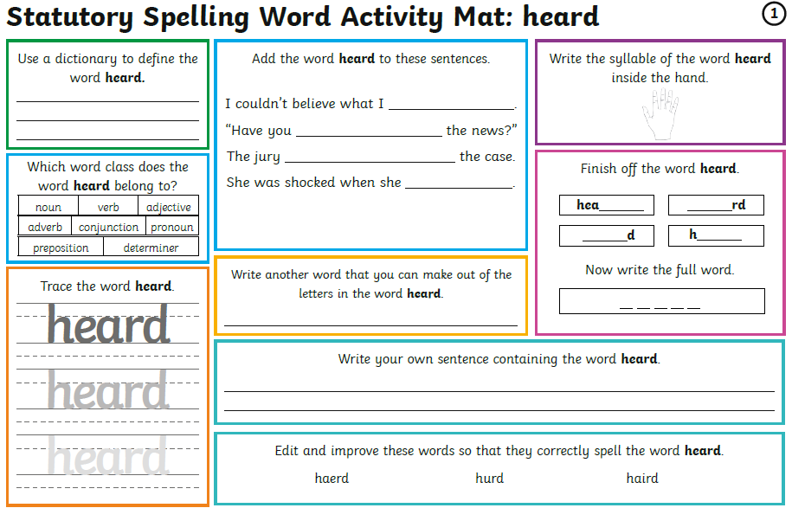

Thursday 14th May 2020 LI: To write a conversation in a comic strip
Now think about where your characters are (in a cave? In a forest? On a beach?) and what they might be doing? (getting dressed? Going hunting? Lighting a fire?)
Then draw a three part comic strip like the comic strip in Ug with speech bubbles showing what your characters might say to each other.

Where are they?_______________________________________
What are they doing?____________________________________

1 | 2 | 3

Thursday 14th May 2020: Spelling & handwriting
Complete the spelling sheet below:
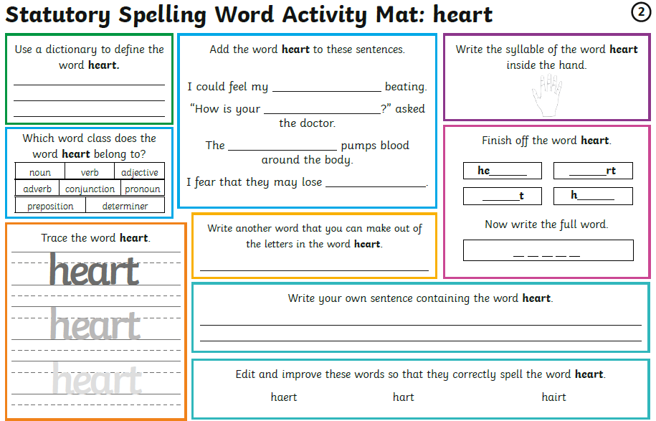

Friday 15th May 2020 LI: To edit and publish a comic strip
Re-read your comic strip to check that all your capital letters are correct (you need capital letters for names and at the start of sentences).
Put in speech marks at the beginning and end of what each person says: “I don’t want to wear stone trousers.”
Try to make your comic strip funny – add some more funny details or jokes if you can.
Then re-write your comic strip using neat, joined handwriting and clear, detailed, coloured pictures. You can email your published comic strips to us and we will put the best ones on the school website!
1 | 2 | 3

Friday 15th May 2020: Spelling & handwriting
Complete the spelling sheet below:
