TOPIC WORK + GEOGRAPHY week beginning Monday 8th June 2020: Green Words
This week we will be looking again at some of the learning from our Going Green topic. Here are some of the words from the topic. Choose 3 words. Put each word in a sentence then draw your own picture to go with it.
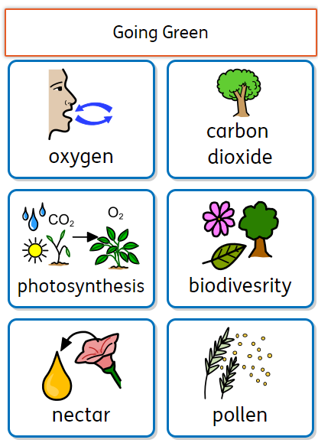 | Word:___________  Sentence:_________  ________________  ________________  ________________  ________________  Picture: | Word:___________  Sentence:________  ________________  ________________  ________________  ________________  Picture: | Word:___________  Sentence:________  ________________  ________________  ________________  ________________  Picture:

GEOGRAPHY Tuesday 9th June 2020: Leaf facts Read these facts about trees and green plants
Tremendous trees and plants  Trees and green plants are amazing. They can make their own food by taking in water and light from the sun.  As they do this they take in carbon dioxide and give out oxygen which humans need to breathe.  This means that trees and green plants are needed to help us stay alive. That’s why it is so important that we look after the trees and forests on our planet. | 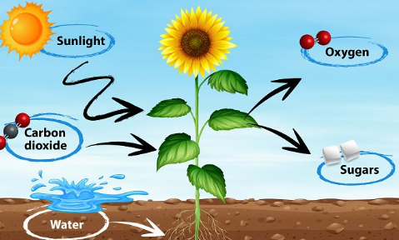

Write some facts about trees and plants on these leaves. Next colour in the leaves and cut them out. Then you can attach them to a stick to create your own tree sculpture like the one in the picture:
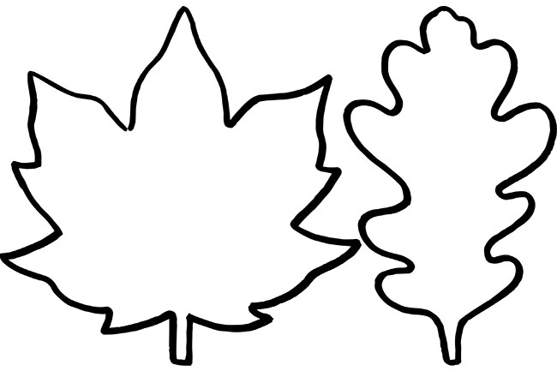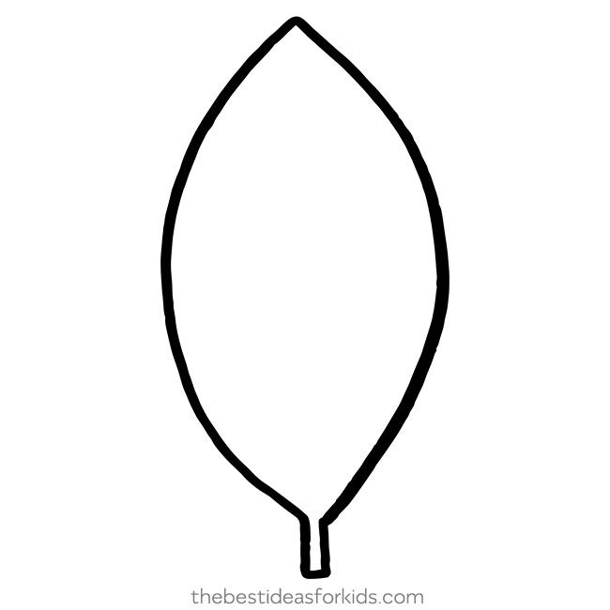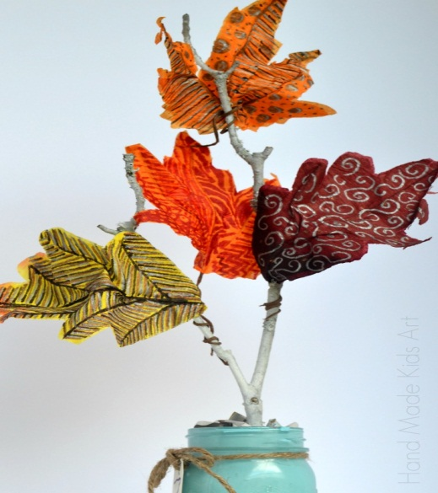
GEOGRAPHY Wednesday 10th June 2020: Designing an eco-friendly city
Read about eco-friendly cities:
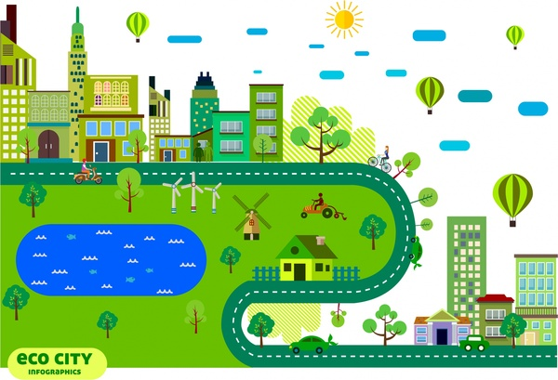 | What is a sustainable, eco-friendly city?  An eco-friendly city is a city where everyone does their best to look after the environment. This should help the people living in there to stay healthy and should also make sure that animals and the natural world are not damaged.  Here are some examples of things you might find in  an eco-friendly city:  - Lots of trees, plants and green space.  - People travelling by bike or scooter instead of by car to keep the air clean.  - Lots of recycling bins to collect and recycle rubbish.  - People re-using bags instead of buying plastic bags and throwing them away.  - Wind farms and solar panels to make clean electricity that doesn’t pollute the air.
Now draw a picture or map of your own eco-friendly city. What will the houses, schools and parks look like? What will you include to make your city clean and green? When you have finished your drawing you could build a model of your city using boxes and cardboard.
