Wider curriculum WB 22.6.20
Monday 22nd June 2020: Geography: Continents
After you watch the continents song on YouTube, label the continents. Can you colour-code each continent? E.g. red for Europe or blue for Asia?
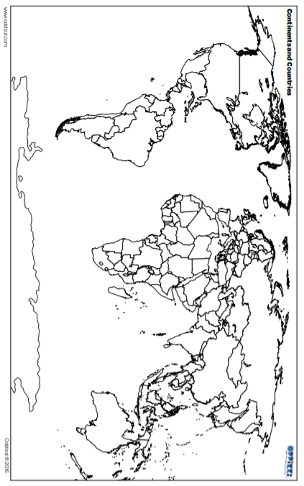

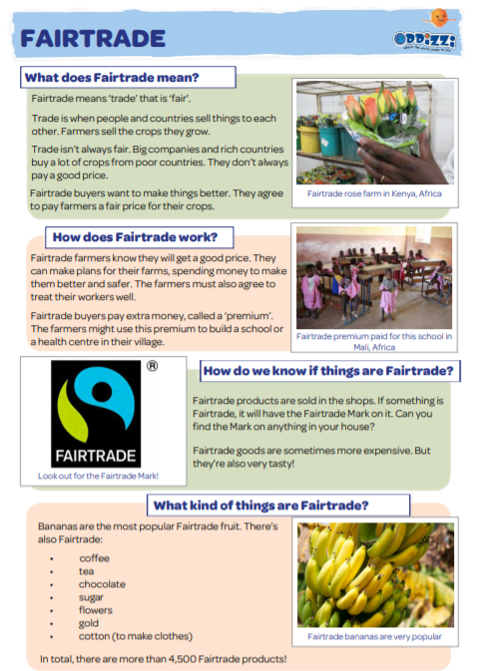
Tuesday 23rd June 2020: Geography: Food and farming.
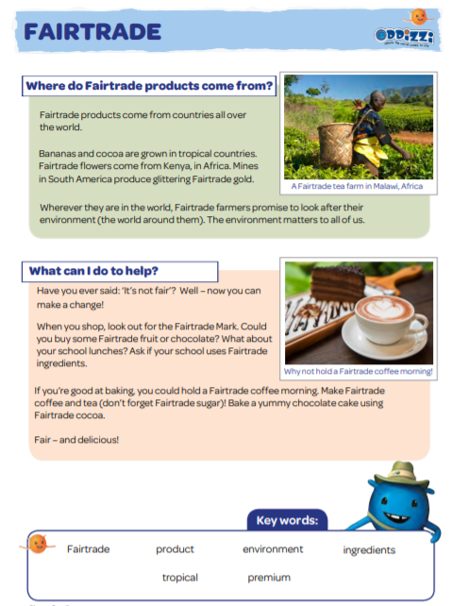
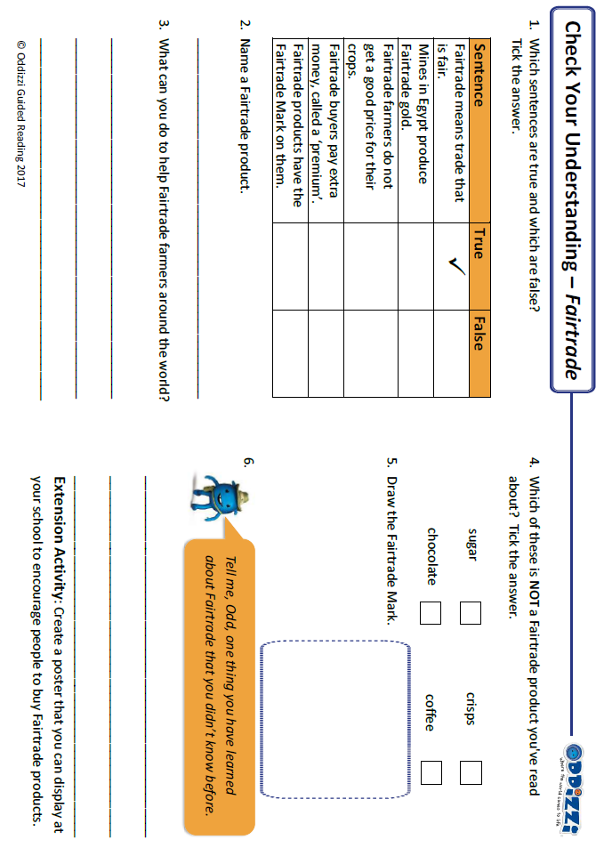
Wednesday 2th June 2020: Food chains

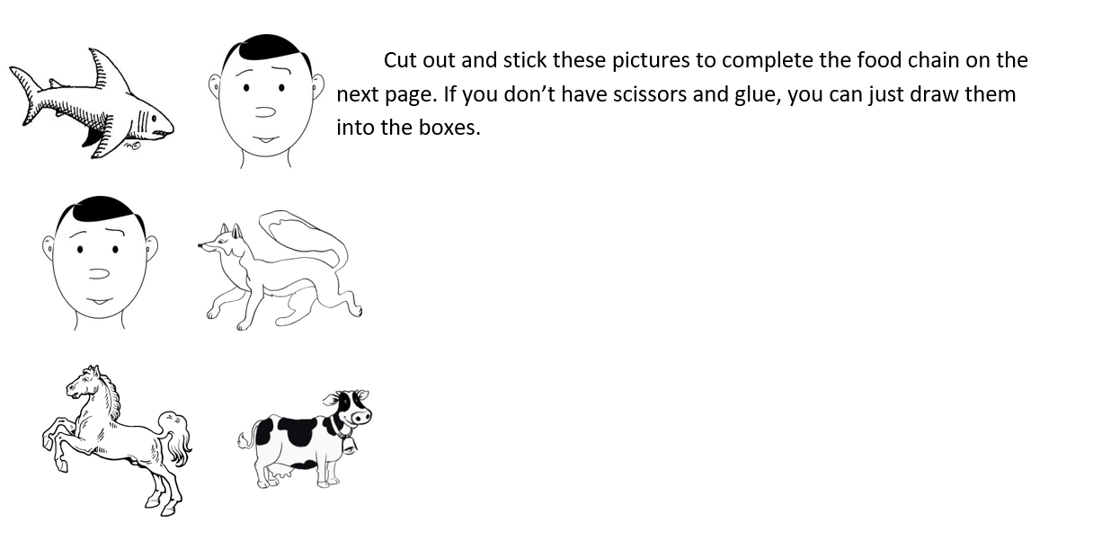

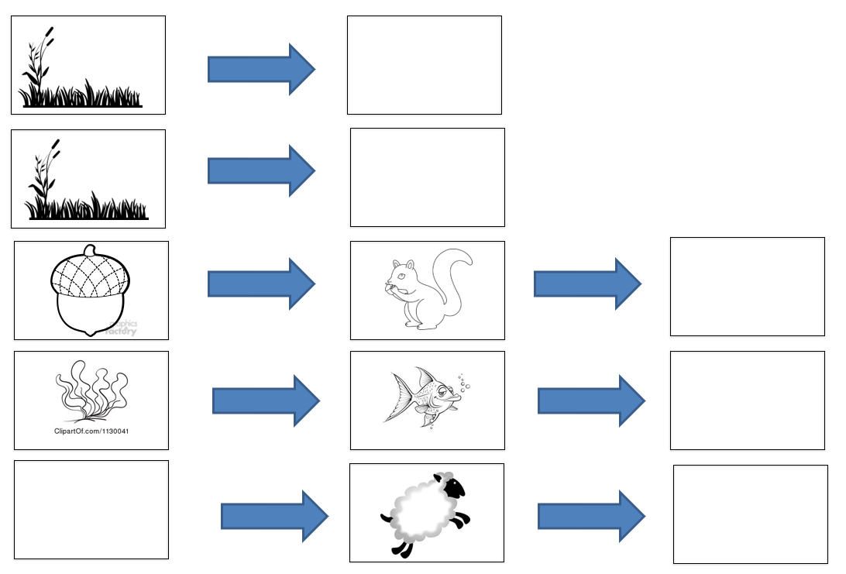
Challenge: On this page, draw your own food chain.

