TOPIC / GEOGRAPHY week beginning Monday 22nd June 2020
This week you will be revising some of your learning from our Water Worlds topic.
Monday 22nd June 2020: Design a poster to help stop plastic pollution in our oceans
Read this information about plastic waste in our oceans:
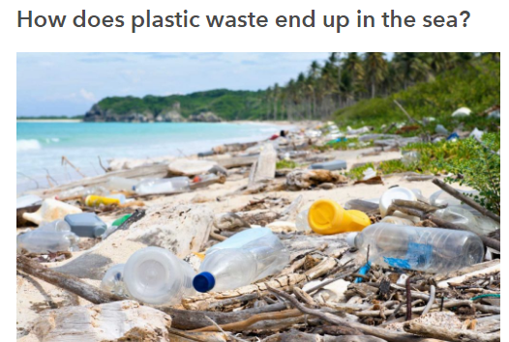 | Why is plastic waste dangerous?  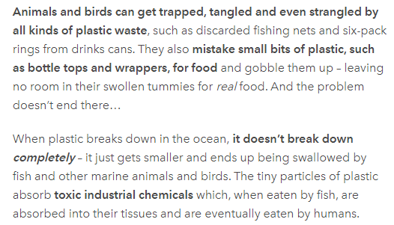 | How can we help?  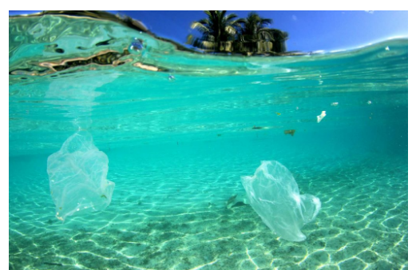
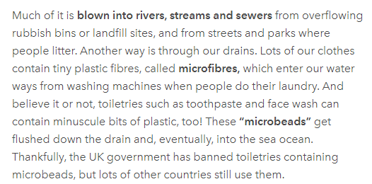 | 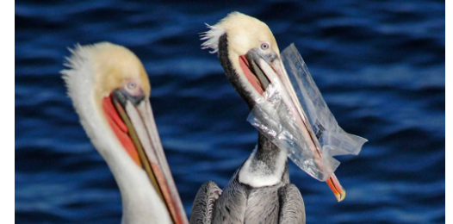 | You can…  Reduce the amount of plastic you buy and use (don’t buy so many plastic bottles)  Recycle as much plastic as you can.  Re-use plastic bags instead of throwing them away.

Now create a poster to persuade people to help stop plastic pollution in our oceans. You should include:
- A catchy title (eg. Save our Seas); - Reasons why we need to stop plastic waste in our oceans; -Ideas for how people can help; - lots of colourful pictures.
Tuesday 23nd June 2020: River map and diorama
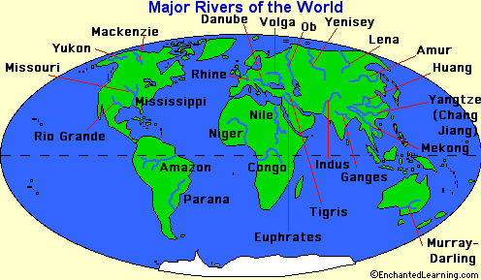 | This map shows the main rivers in the world.  Name a river in…  South America  Africa  _____________________  Asia  _____________________
The Amazon is the world’s longest river. It travels through the middle of the Amazon Rainforest past enormous trees and amazing wildlife. Use the pictures here to help you create an Amazon river diorama in a shoe box or cereal box.
If you have internet access you can find out more about Amazon wildlife by googling ‘bbc bitesize amazon river’ or clicking this link: https://www.bbc.co.uk/bitesize/articles/zvvmjhv
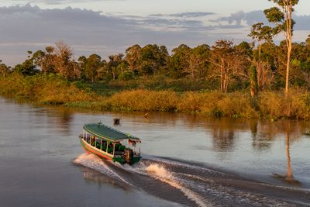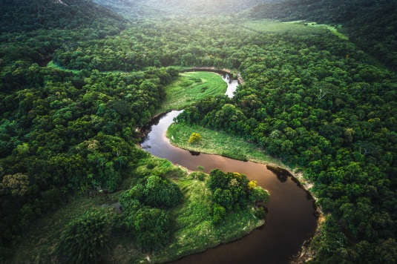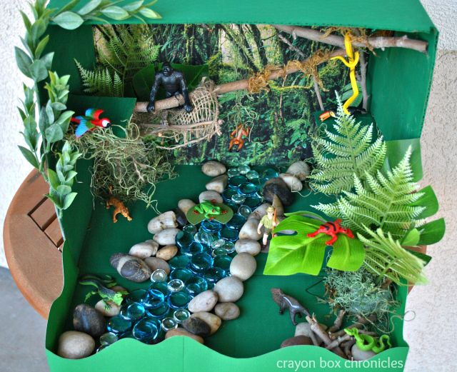
Wednesday 24nd June 2020: Make a waterfall
Read this information about waterfalls:
A waterfall is a place in a river where water spills suddenly downward.  Waterfalls are known for their beauty and awesome power. The world's tallest waterfall is Angel Falls, in Venezuela. Its water plunges 3,212 feet (979 metres).  Smaller or less steep waterfalls are sometimes called cascades. | 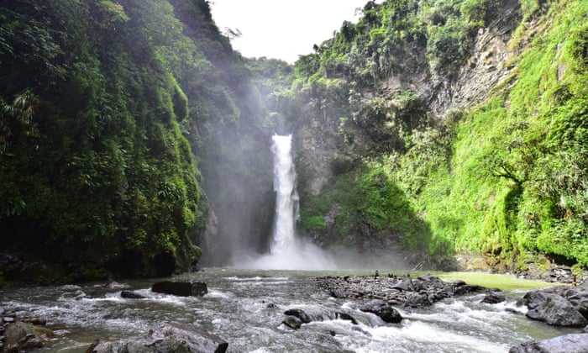

Now try building your own waterfall so you can watch the effect of the water cascading down.  You will need:  A bath or sink  Pots, pans or buckets of different sizes  A tap, hose or jug  Experiment with pouring water over different sized pots, pans or buckets.  What do you notice? When does the water flow fastest or slowest? When do you get the biggest splash? | 