Topic / History week beginning Monday 29th June 2020
This week you will be revising the Ancient Worlds topic and doing some thinking about Ancient Egypt.
Monday 29th June 2020: Ancient Egypt and the river Nile
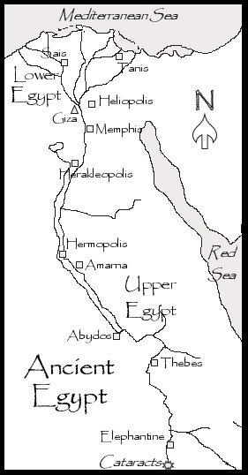 | Use pencils or colouring pencils to shade the different places on the map on Ancient Egypt.  Shade in blue:  The Mediterranean Sea  The Red Sea  The river Nile  Circle then shade in yellow:  The pyramids at Giza  The settlements at Memphis, Heliopolis and Thebes

Tuesday 30th June 2020: Hieroglyph cartouche
Ancient Egyptians writing used picture symbols called hieroglyphics.  Use the hieroglyphics to write your name here: | 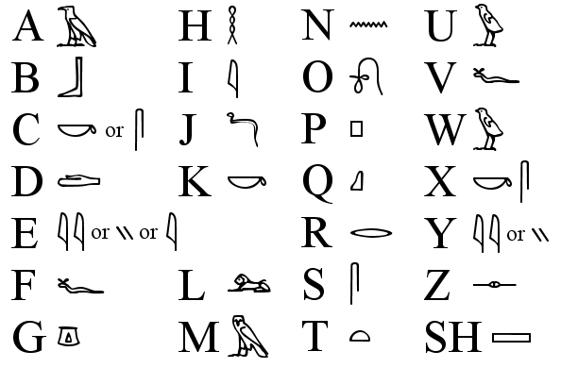
Ancient Egyptian Kings were called Pharaohs. They often had special plates called cartouches with their name carved on, made from stone or sometimes even gold.
Use some cardboard and /or coloured paper to make your own cartouche using the hieroglyphs in your name.
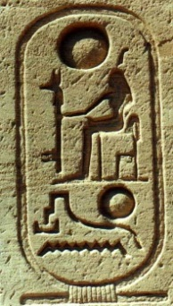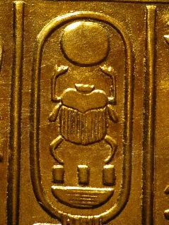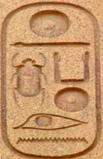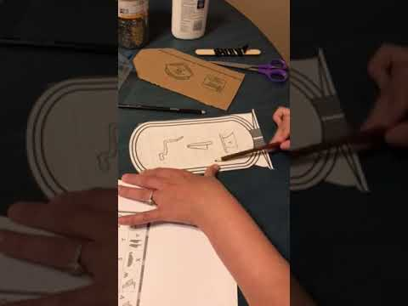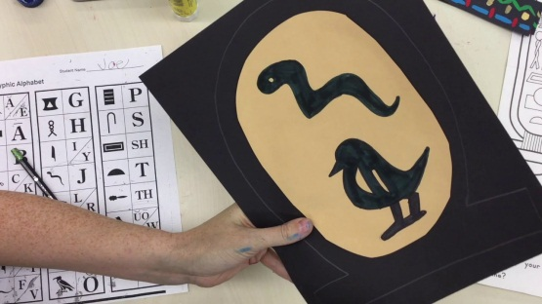
Wednesday 1st July 2020: Make an Ancient Egyptian tomb
Tombs and the Afterlife  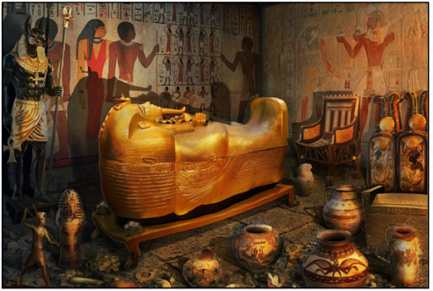 | Ancient Egyptian kings, queens and rich people were placed in a special space called a tomb when they died.  They believed that after death their body would travel to another world where they would lead a new life. This was called the Afterlife. They would need all the things they had used when they were alive, so their families would put those things in their tombs. Furniture, games and even food was placed in the tombs for the long Afterlife journey! The tomb walls were painted with scenes from the dead person’s life.

Use a cardboard box to create an Ancient Egyptian tomb with tomb paintings and objects that the person might need for the Afterlife.
