Thursday starter: Maths Crossnumber
Use the formal method of multiplication and division and write the answers in digits
(Use a calculator to check your answers at the end)
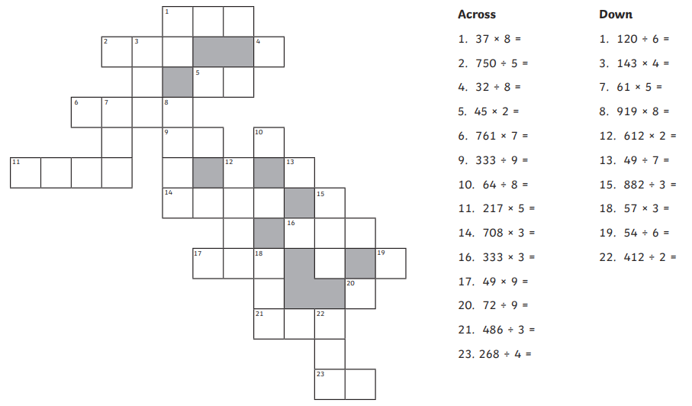

Friday Maths challenge
