Year 5 Home Learning Activity Grid
The Victorians
Who was Queen Elizabeth? | What were Victorian punishments for children who broke the rules? | Create your own Victorian word bank. | What was life like in a Victorian workhouse? | Read a story by Charles Dickens! | Cook a Victorian recipe, take a photo and bring it into school!
What was it like in a Victorian home? Use a shoebox to create your own! | Where did the Victorians go on holiday? What was it like? | Draw yourself as a Victorian! Are you rich or poor? | Google ‘Horrible Histories’ and watch them on YouTube! | What did Victorian homes look like? Do you live in one today? | What can you find out about the Victorians?  http://www.bbc.co.uk/schools/primaryhistory/victorian_britain/
Can you create your own clothes-peg doll? | Write a newspaper article announcing Queen Victoria’s coronation. | Research famous Victorian inventions. | Make your own puppet show! Can you write a script for the puppets you have made? | Design an outdoor game for Victorian children to play. | Research Victorian handwriting. Can you write like a Victorian?
Create a job advert for someone to work as a maid in a rich household. | Who was JMW Turner? Can you create some artwork in his style? | 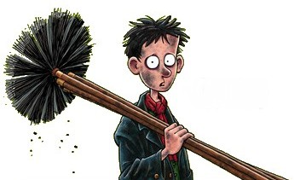  What food did the Victorians eat? Design your own menu! | Who was Charles Dickens? What did he write? | Can you run William Morris’ business  http://www.wmgallery.org.uk/learning/activities-online | 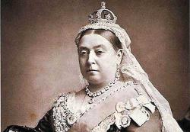  If you were Queen Victoria, what laws would you have made and why?
