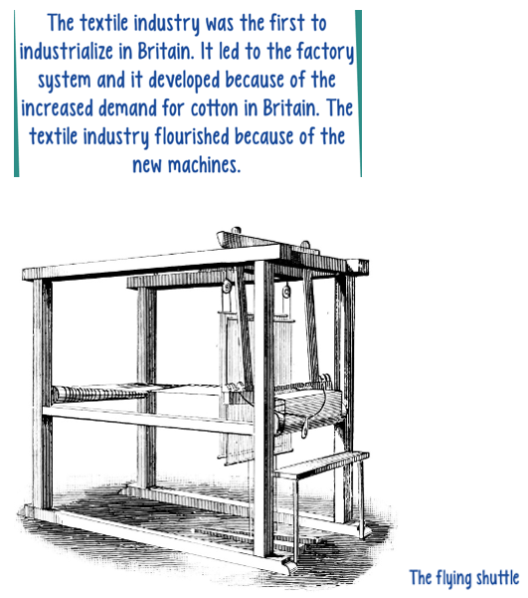

Carry out some research.

* You may want to watch this video: <https://www.youtube.com/watch?v=PCpYJ7iiS40>
* What was the ‘flying shuttle? What was its purpose?
* How did it change the way people in the textile industry did their job?

Also, find out more about these inventions:

