

**Task 2**

**Compare the two ways of producing cotton, and explain why the mill is so much more efficient, produces so much more cotton, and most importantly allows for cotton to be much cheaper. Answer the questions below.**

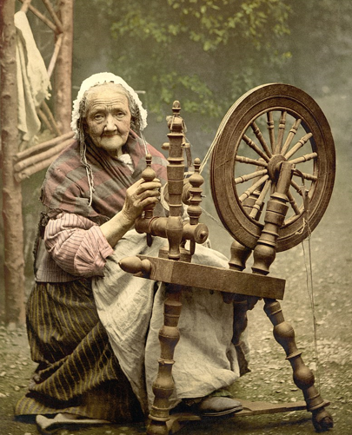 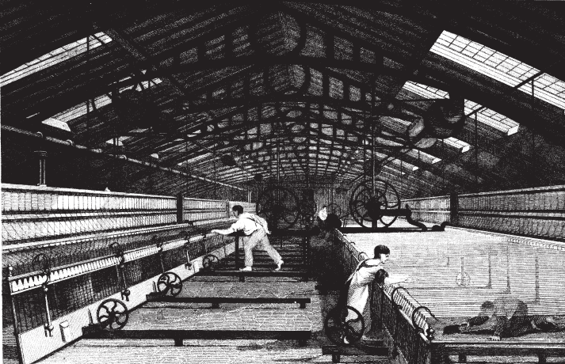

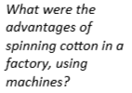

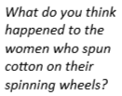

How was cottHon spiHoH