Talking Point
Dear children and parents,
Here is a little talking point to discuss as a family when you get a spare moment, maybe at lunch time or tea time, or any other time when you like to chat.
Do you have a pet? Have you ever wanted a pet? If you could have any animal as a pet, what would it be?
This week’s talking point is:
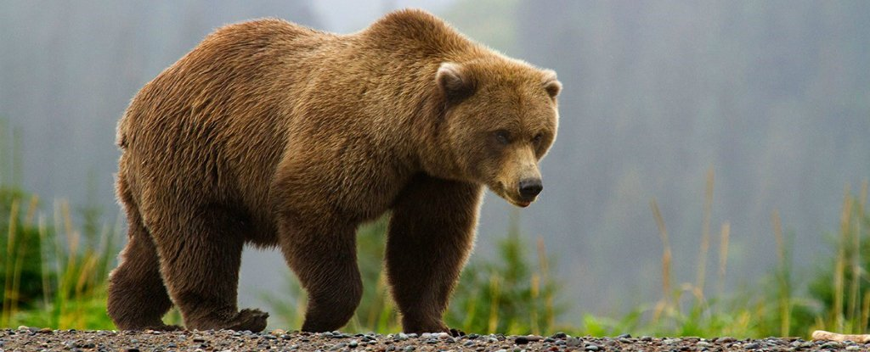
A bear would make the best pet
Do you agree or disagree? Explain why
You can use these sentence stems to help you discuss:
I agree because
I disagree because
I would like to challenge this because
Building on what __________ has said, I would like to add

