History Task 2 - Additional Information
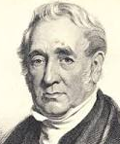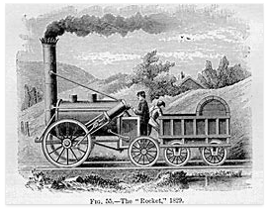

The Locomotive (Train)
In 1801 Richard Trevithick developed a steam powered carriage that carried passengers on roads. He developed his invention further and in 1804 created the first locomotive to run on rails (i.e. the first train). Trevithicks’ ideas were further developed by the George Stephenson. Find out more about Stephenson and why he is also known as the ‘father of railways’.
- Stephenson was one of six children born into a poor mining family in Wylam, Northumberland on 9 June 1781.

- His father, Robert, worked on the engines that were used to pump water from the mines and the young George Stephenson longed to be in charge of these steam-driven engines.

- As a young boy he had a number of jobs before going down the pit to mine coal at the age of ten. At 14 he became an assistant fireman and later worked on the winding machine which pulled the cages of miners up from the pit face.

- George did to know how to read or write until he was 18. He went to night school and taught himself over a three-year period. He wanted to learn as much as possible about engines.

- After George’s wife died, leaving him with a young son, Robert, George decided to go to Scotland and study engines. Later Robert helped his father on many projects and became a famous engineer and bridge builder in his own right.

- In 1811 George fixed the broken pump engine at a local flooded mine and impressed the owners. This led to him being promoted and acknowledged as a local expert on engines.

- He persuaded local backers to support his plan for a locomotive engine. In 1814 he built ‘Blucher’, his first locomotive, which travelled at 4mph whilst pulling a load of 30 tons.

- in 1823 Stephenson opened a locomotive factory in Newcastle. Two years later the first journey of his ‘Locomotion No 1’ with its carriage ‘Experiment' took place. The ‘Locomotion’ cost £500 to build, could carry 450 passengers and travel at 15mph.

- In 1828 the Railway Board announced a competition to determine which was the best engine. Stephenson’s ‘Rocket’ beat four other entrants on the grounds of weight, speed, power and reliability. The ‘Rocket’ successfully completed ten laps of the track at Rainhill achieving the dazzling speed of 29 mph on the final lap.

- The Stockton to Darlington line was the world's first passenger railway. The Manchester Liverpool Railway was opened in 1830 and in 1838 the line from Birmingham to London was completed.

- This first ‘train’ was very slow and initially scared a lot of people but soon the early railway lines between Liverpool and Manchester and Stockton and Darlington were accepted and people began to realise that Rail had a lot to offer industry and society in general: goods could now be transported faster and in even greater quantities, people could get around the country much quicker and holidays out of the city were possible for the first time, newspapers could be sent across the country and town developed quickly.

