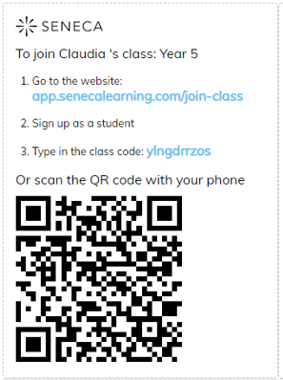

**There are three ways to access your Seneca classroom and tasks:**

1. **Type or copy and paste this link:** app.senecalearning.com/dashboard/join-class/ylngdrrzos
2. **Go to:** app.senecalearning.com/join-class; type in class code: **ylngdrrzos**
3. **Scan QR code** with phone

