Changing States: Evaporation and Condensation
The Water Cycle
Go to the BBC Bitesize Website – Science and watch the clips
https://www.bbc.co.uk/bitesize/topics/zkgg87h/articles/zydxmnb
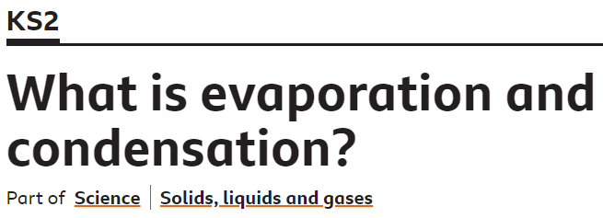
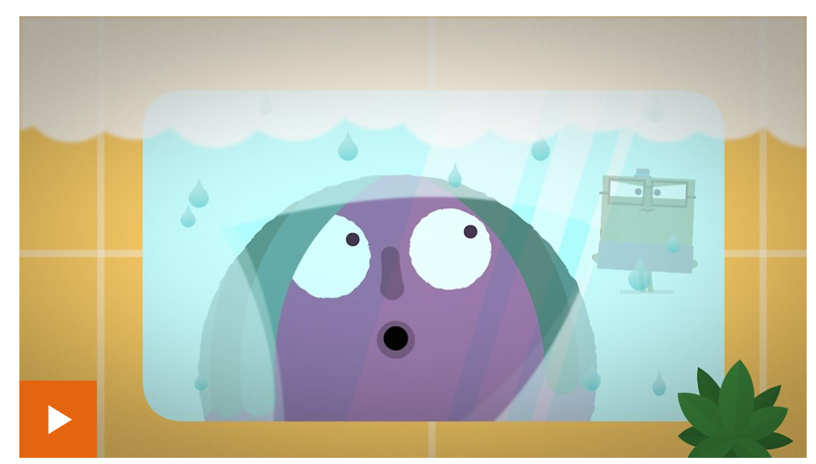
https://www.bbc.co.uk/bitesize/topics/zkgg87h/articles/z3wpp39
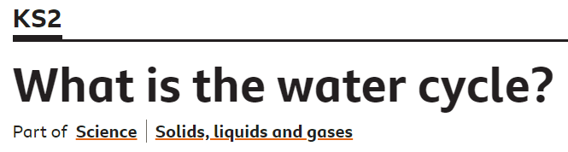
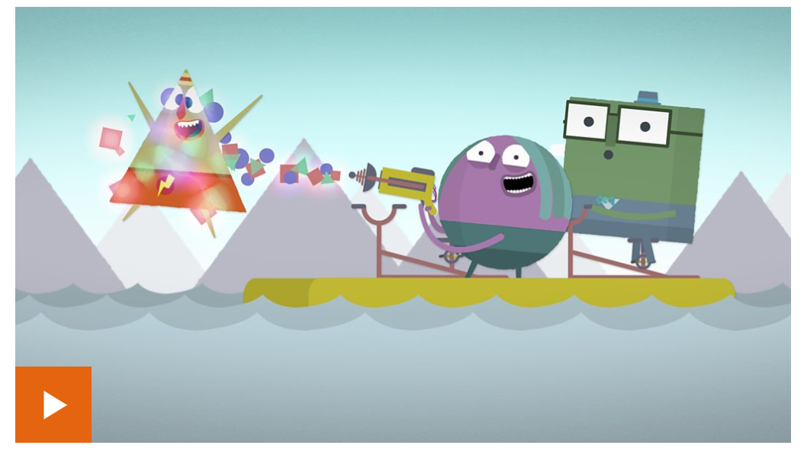
Go to youtube and sing along to this song about the water cycle.
https://www.youtube.com/watch?v=TWb4KlM2vts
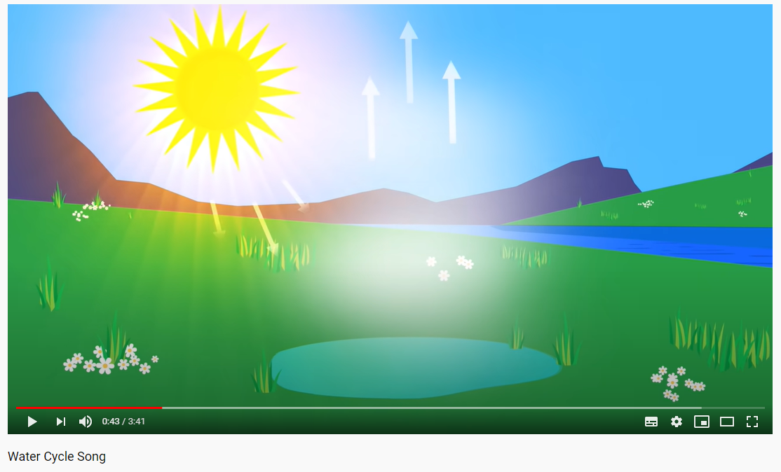
If you don’t have Internet access, you can read the information below to help you.
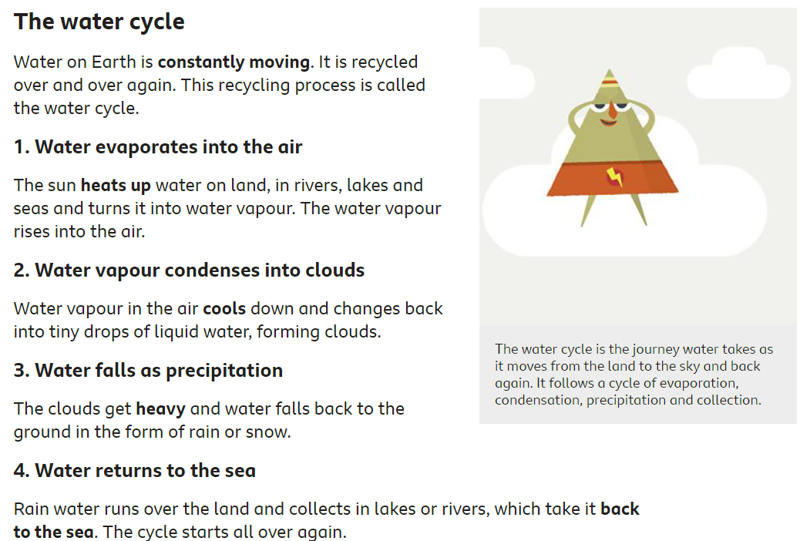
Match the words to their meanings.
Precipitation |  | When the sun heats up water from the sea and it goes into the air
Condensation | 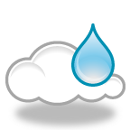 | Rain, hail, sleet and snow that falls from the clouds
Evaporation | 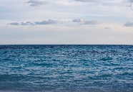 | When water flows through the rocks and soil underground.
Groundwater flow | 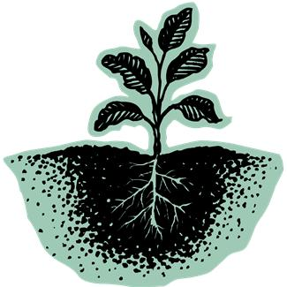 | When the water vapour cools down and forms clouds.
Surface run-off | 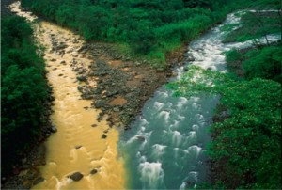 | When the sun heats up water from the leaves on the trees.
Transpiration | 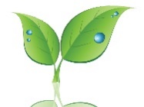 | When the water runs off the surface of the ground.

Add the key words to the diagram:
condensation precipitation
evaporation groundwater flow
surface run off
