- If you have internet access, log onto ActiveLearn and go to Science Bug.
- What information can you find out about different types of soil?
- Complete the worksheet
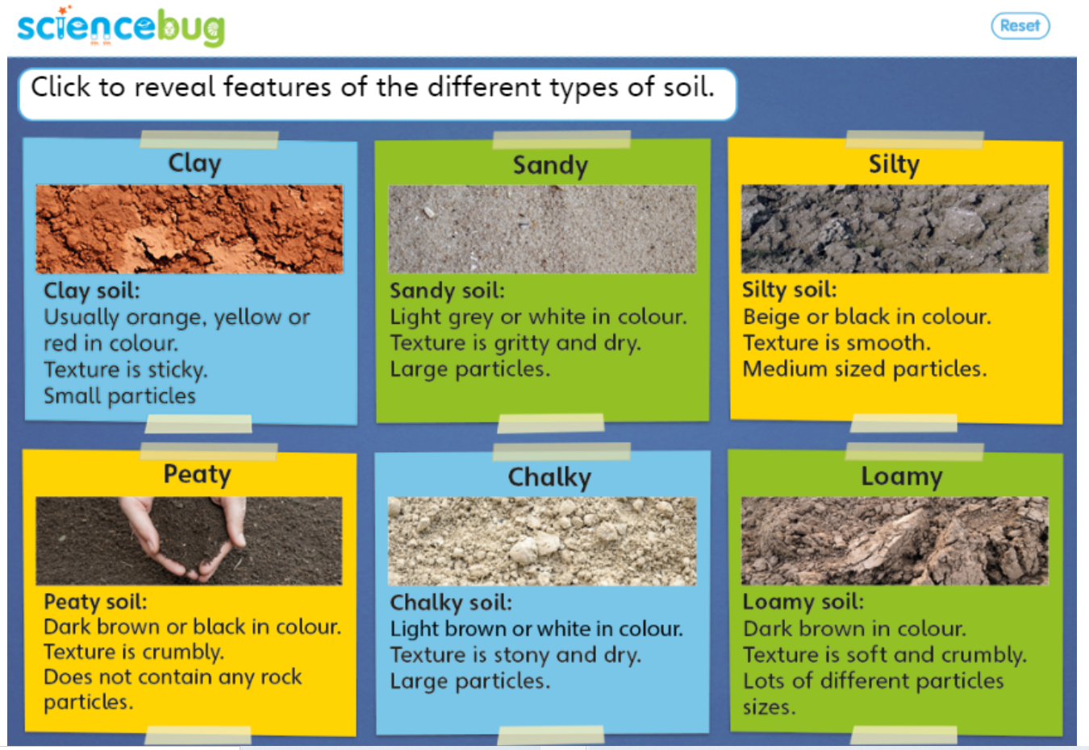

- Read your Knowledge Organiser (which you received at the start of this unit).
- Tick what you have learnt in this unit ‘Rocks and Soil’?
- What else would you like to find out?

- On the Rocks and Soil – A3 page, create a poster about all that you have learnt about rocks, fossils and soil (i.e. different types of rocks and soil, how fossils are formed).
- Include headings and key facts.
- Include pictures, labels and captions.

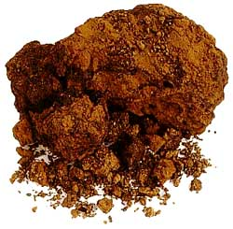
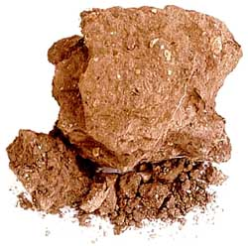
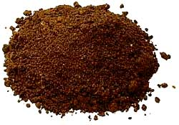
Draw an arrow to match the soil type to the picture.
Sticky and waterlogged.
Thin and dry.
Made up of rotting plants.
Clay
Sandy
Loamy
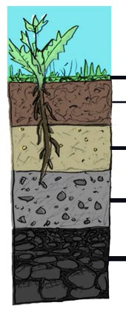
Soil is made up of:
- Weathering of R_ _ _ _
- Mi_ _r_ _ s
- W_t _ _
- Or_ _ _ _ _ M _ _ _ _ _
- Liv_ _ _ Org _ _ _ sms

Bedrock
Topsoil
Organic layer
Subsoil
Parent material

