**Magnetism**

1. **Go to the BBC Bitesize website - KS2 Science Magnets (bbc.co.uk/bitesize/topics/zyttyrd).**

Watch the various video clips and complete the activities.

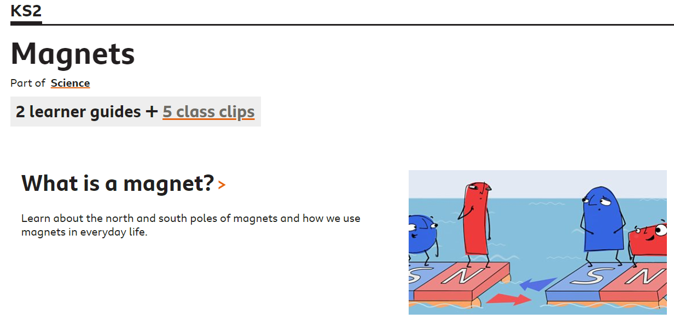 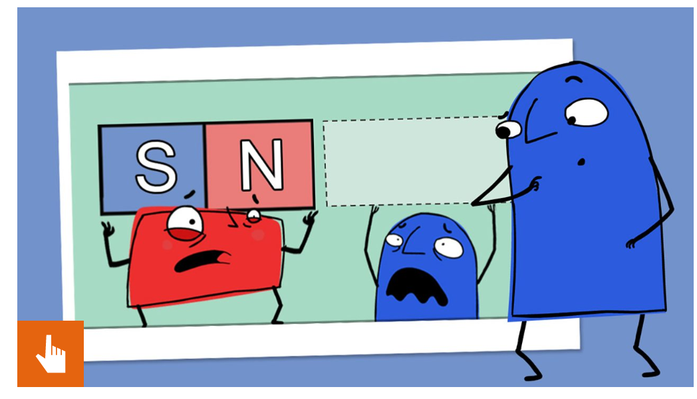

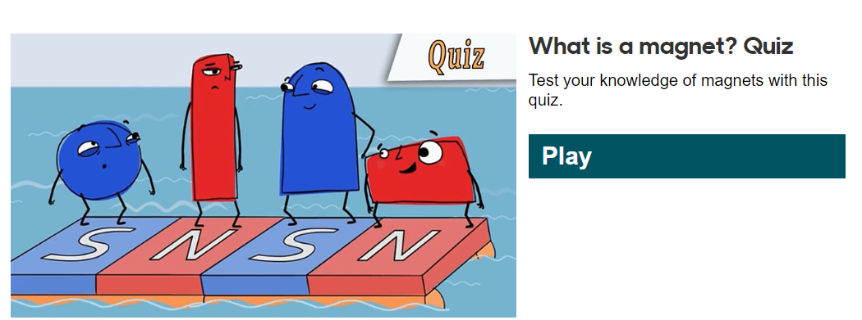 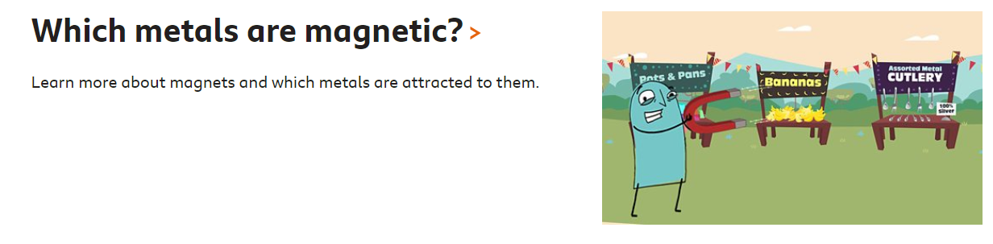

1. **Log onto Active Primary Learn and click on Science Bug.**

Watch video clip about Magnets.

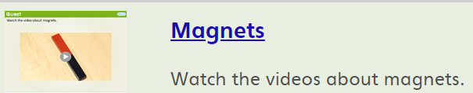

Look at the pictures below. What do you think the missing word (?) is?

