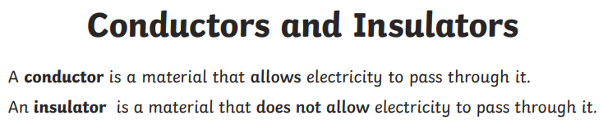
Which items are conductors and which ones are insulators? Fil out table.
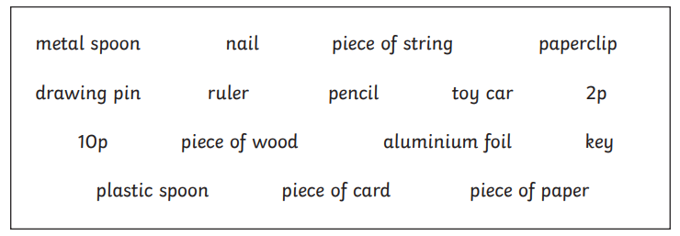
Conductors | Insulators

Why are insulators important?

