Science: Classification Keys
Why do we scientists use classification keys?
To identify things based on their features or to group things together.

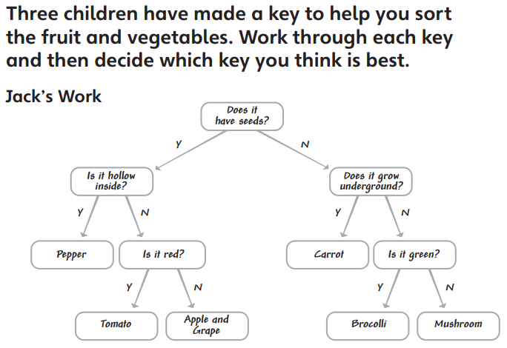
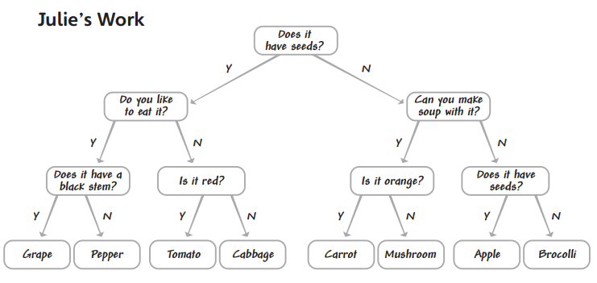

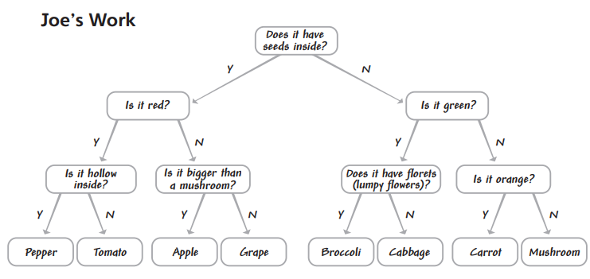
Now can you create your own key to help you sort fruits and vegetables.

