Rivers
Think back to our ‘River deep’ topic. Remember we learnt about the journey of a river. Watch Youtube: ‘A river’s Journey song’ and read ‘The stages of a River’ on primary homework help. Now complete the activities.
Task 1: Match the Rivers keywords
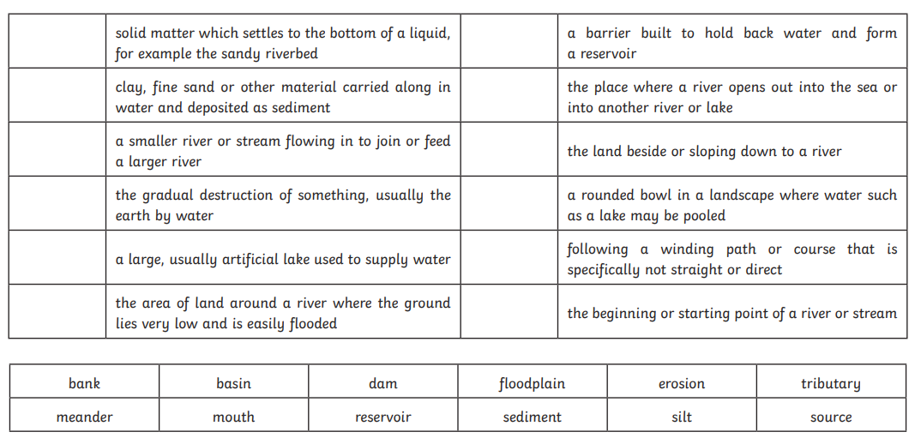
Task 2: Rivers wordsearch
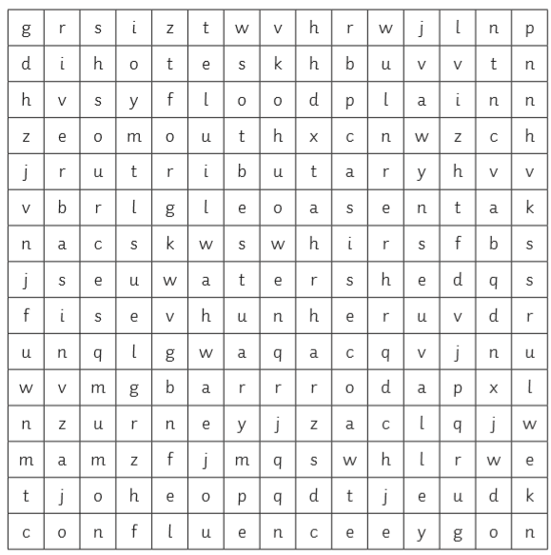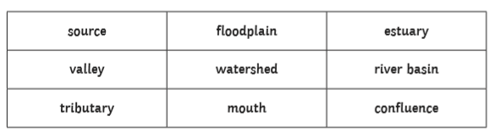
Task 3: Labelling parts of a river
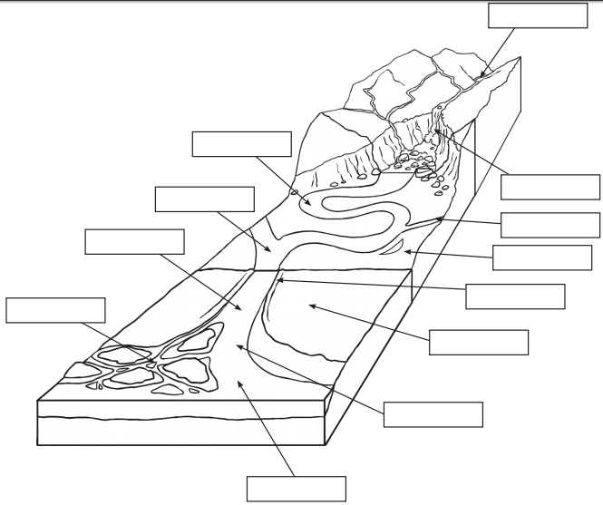

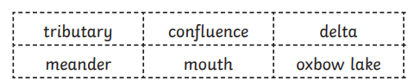
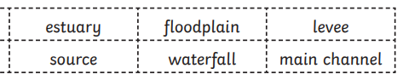
Now colour the diagram in.

Labelling map: UK seas rivers
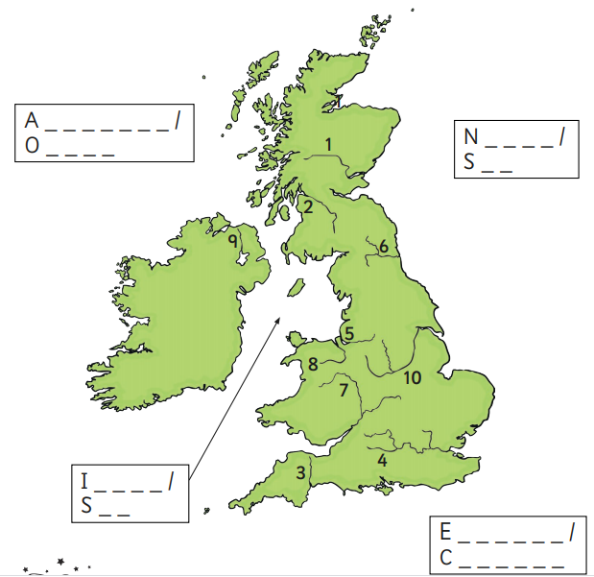
Use google maps and the internet to help you complete this activity. First label the seas that are around the United Kingdom.
Now look on the map of the UK, there are numbers labelled on different areas. Which number are these rivers located?

