If you have access to a computer, go to www.bbc.co.uk/programmes/p02mwviy
Meet Nathan, a Christian boy. How do you think he spends his time?
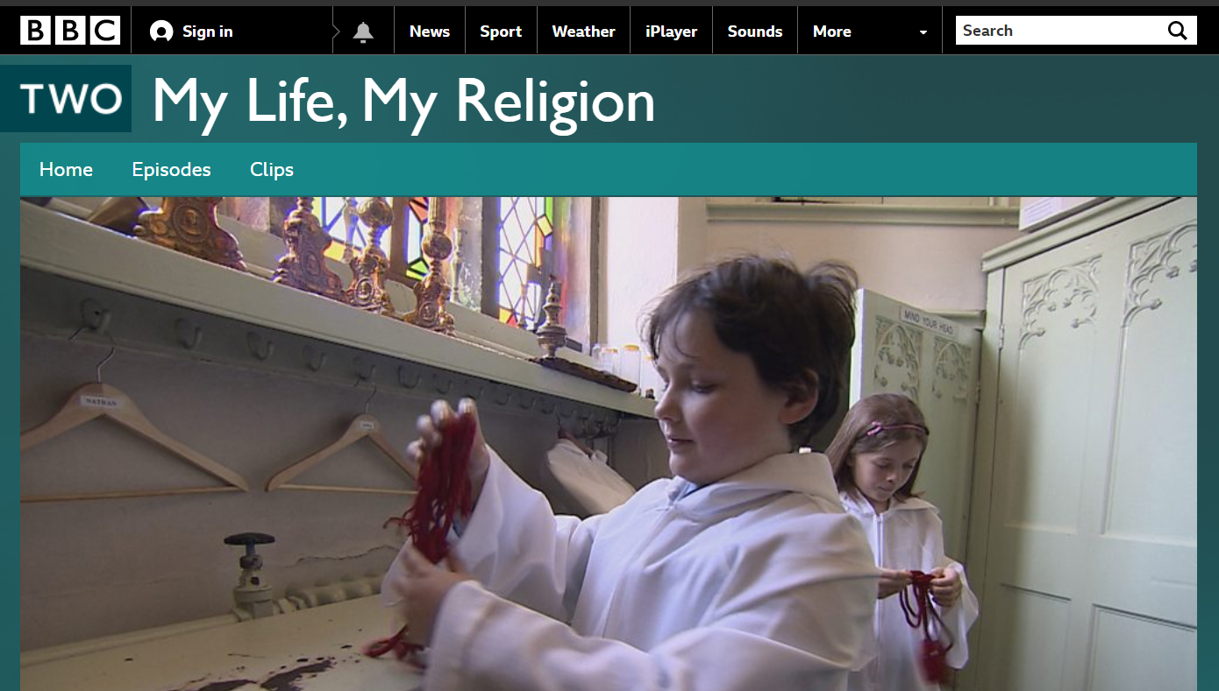
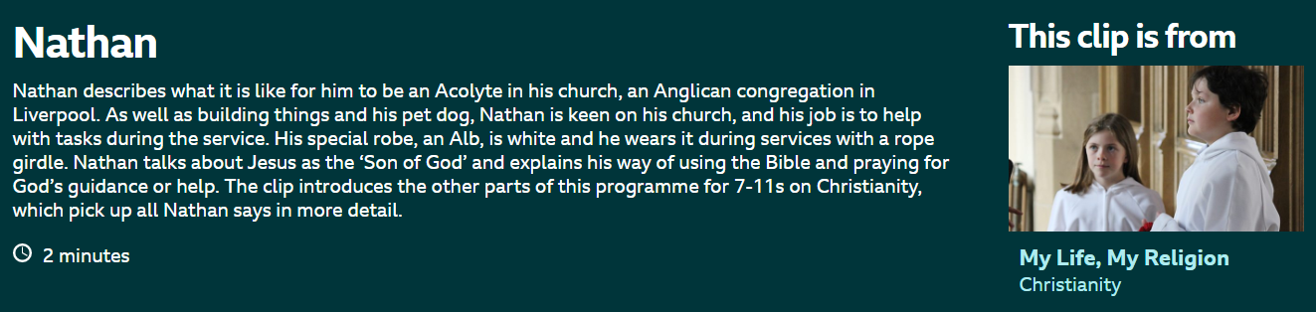
Look at Nathan’s weekly timetable.
Monday | Tuesday | Wednesday | Thursday | Friday | Saturday | Sunday
9.00am School  6.00pm  Say Grace before Dinner  8.00pm  Bedtime Prayer | 9.00am School  6.00pm  Say Grace before Dinner  8.00pm  Bedtime Prayer | 9.00am School  4.00 Choir Practise (Church)  6.00pm  Say Grace before Dinner  8.00pm  Bedtime Prayer | 9.00am School  6.00pm  Say Grace before Dinner  8.00pm  Bedtime Prayer | 9.00am School  5.00pm  Cub Scouts  6.00pm  Say Grace before Dinner  8.00pm  Bedtime Prayer | 9.00am Complete Homework  2.00pm  Football Club  6.00pm  Say Grace before Dinner  8.00pm  Bedtime Prayer | 9.00am  Sunday School  12.00pm  Church Service  6.00pm  Say Grace before Dinner  8.00pm Bedtime Prayer

Complete a weekly timetable of your normal week.
Monday | Tuesday | Wednesday | Thursday | Friday | Saturday | Sunday

- What does Nathan do that is similar to what you do in your week?
- How is your week different to Nathan’s week?

