The Rosa Parks Story
Go to the BBC Bitesize Website (https://www.bbc.co.uk/bitesize/topics/zjkj382/articles/zkhknrd) and watch the video clip about Rosa Parks. Then do the online activity.
If you don’t have access to the Internet, you can read the information below.
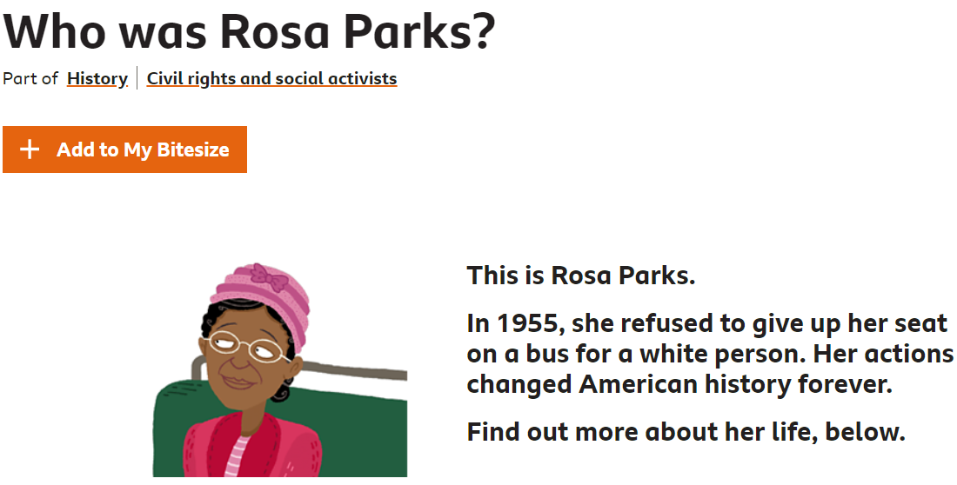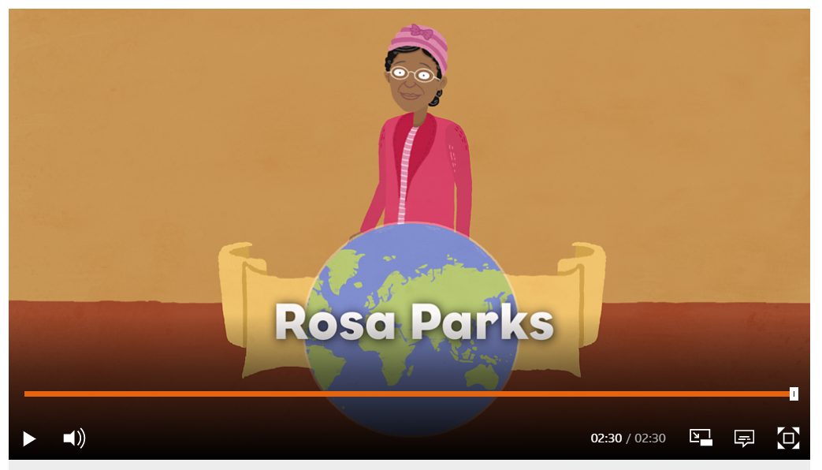

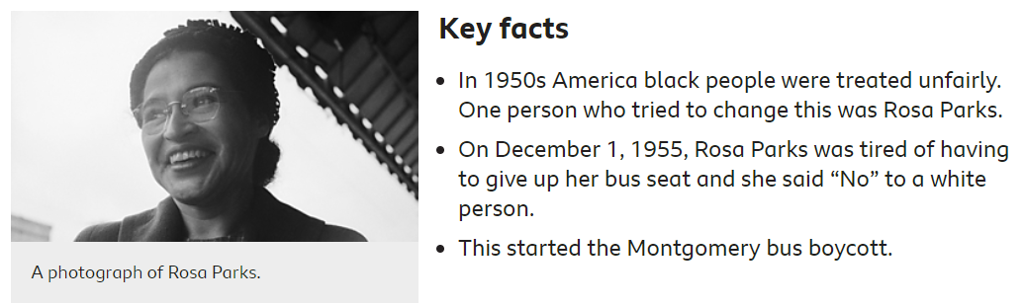
Think about what you have learnt about Christianity.
Rosa Parks was a Christian. Why do you think she didn’t give up her seat on the bus for a white person?
___________________________________________________________________________________________________________________________

Why do you think black Americans stopped using the bus for a whole year? What change did they want to see?
___________________________________________________________________________________________________________________________
The law did change and both black and white people were allowed to sit together on the buses. How do you think Rosa parks inspired people?

