RE Friday 1st May 2020
In RE, we have been learning about different festivals. If you have Internet access at home, please re-visit the BBC Bitesize website and choose a festival you would like to know more about i.e. Diwali, Passover, Easter.
https://www.bbc.co.uk/bitesize/subjects/z7hs34j
You can watch various animated clips (cartoons) but there are also some real life documentary clips.
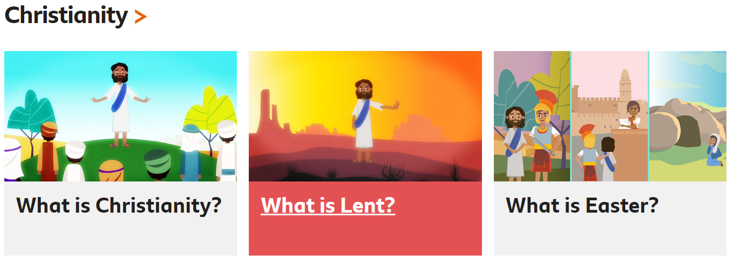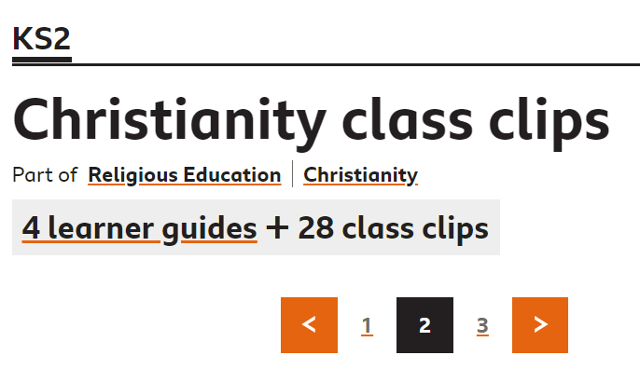
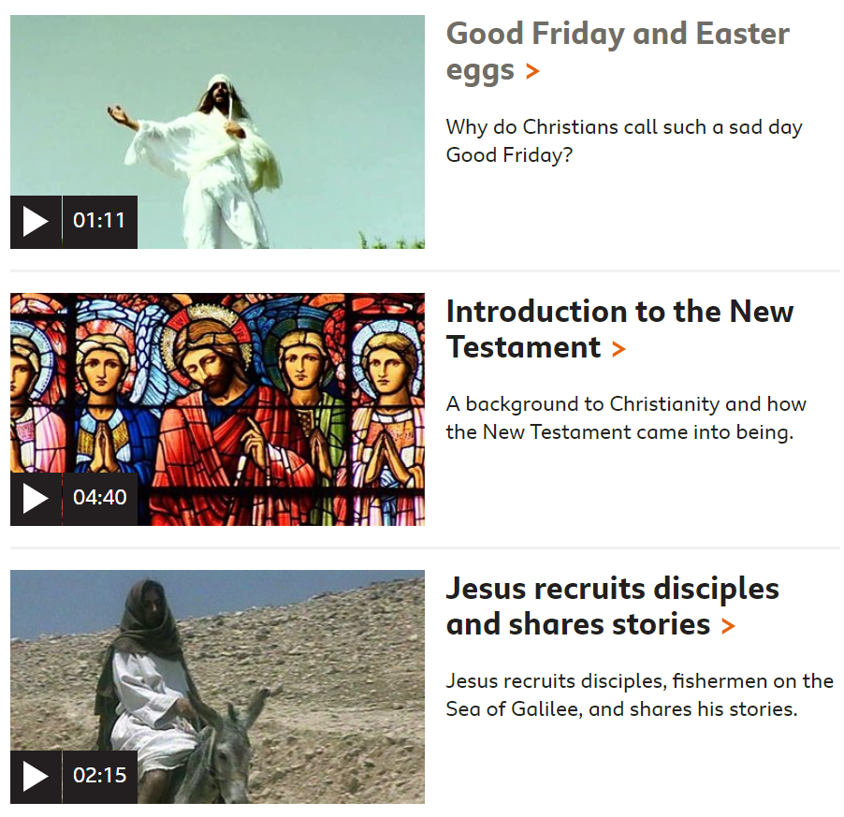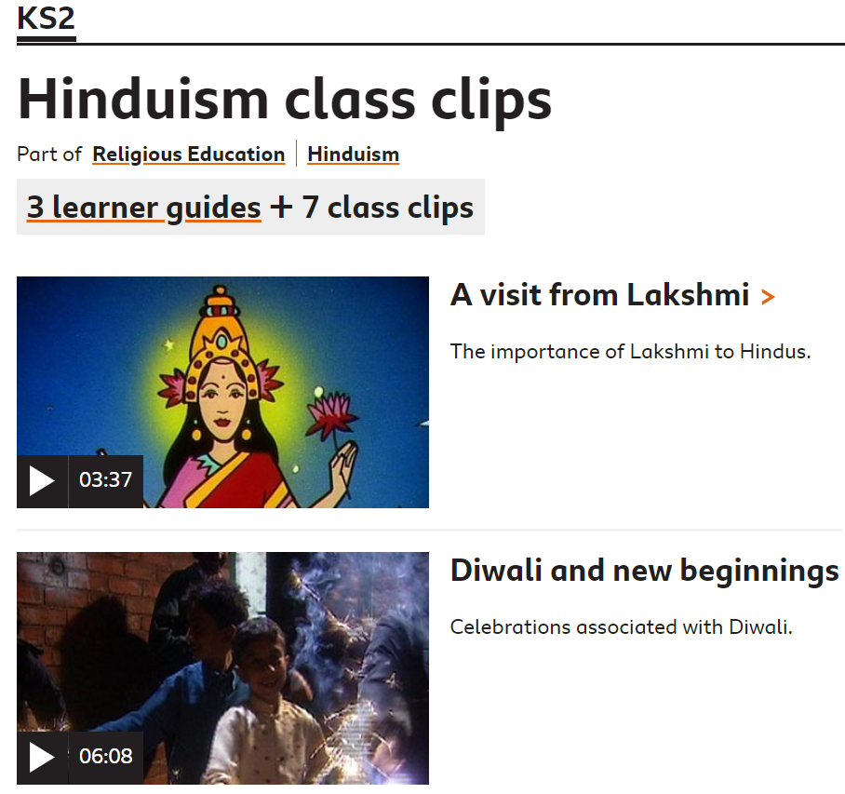
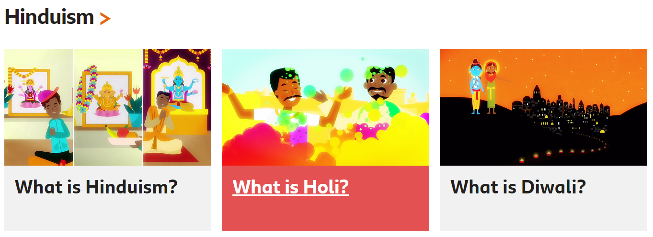
Use the information you have learned to help you design a poster/information leaflet about the festival.
You should include:
-Title
-Subheadings/Questions: What do people eat during this festival? What story do they remember? Where do they pray/worship?
-Pictures with captions

