These items are important to a Christian child or a Christian family.

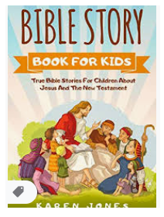  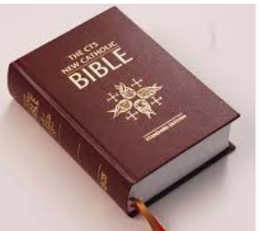 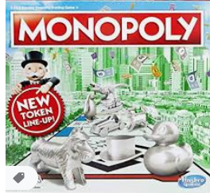

 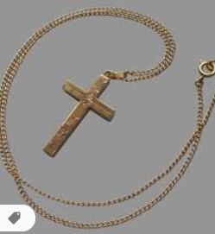  

1. Below, draw items that are important to you and your family. You can draw religious items but you can also draw your favorite food/dinner, sport, place or holiday.
2. How is your life similar and different to that of Christian family?

|  |  |
| --- | --- |
| Similarities | Differences |
|  |  |
|  |  |