Friday 12th June 2020
LI: To describe what happens at Holy Communion and explain why it is celebrated by Christians.

If you have internet access, go to the BBC Bitesize website – KS2 Holy Communion (www.bbc.co.uk/bitesize/clips/zwcd2hv) and watch the clips about the Last Supper and the Holy Communion.
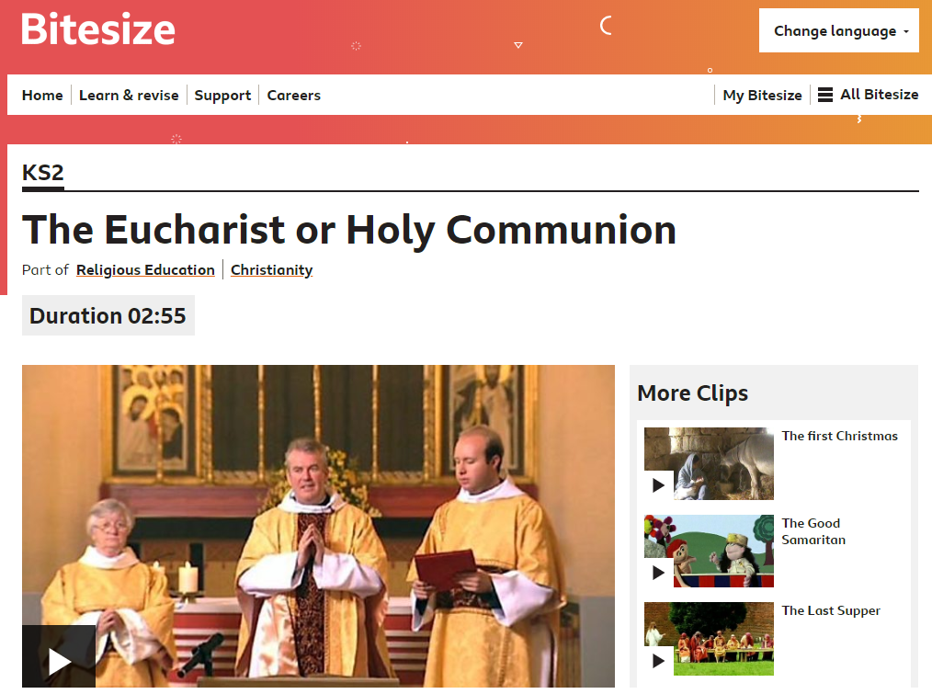

What are Christians reminded of when they drink the wine in church?
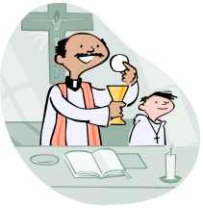


What are Christians reminded of when they eat the bread in church?


Special food are sometimes eaten on special occasions.
Write down as many special food as you can think of and when they are eaten.
Special food. | When it is eaten.


