Rainforests of the world
Use google world map and the internet to help you complete the activities.
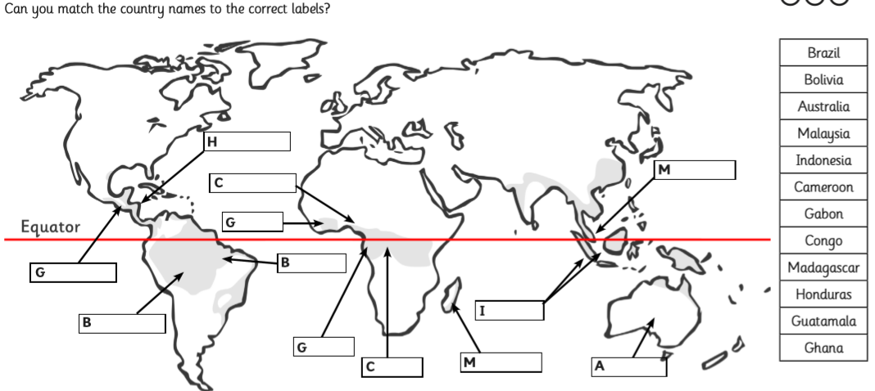
(The shaded areas are the rainforests)

- Now can you locate South America on the World map.
- What is the difference between a forest and a rainforest?

