Music All Around Us
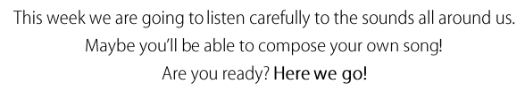
Task 1: Listening
On Youtube, listen to: John Cage Water walk
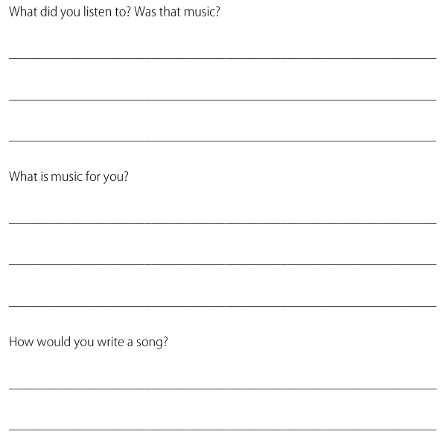
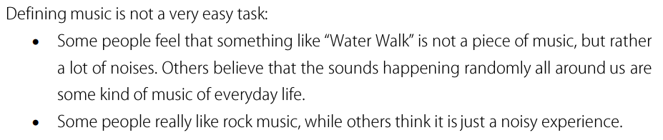

Now listen to: ‘Tarambé Percusión Corporal /Body Percussion ‘ on youtube

This whole piece was made with sounds made with the body clapping, humming, tapping feet.
How many sounds can you make with your body?
Task 2: Making instruments with items at home
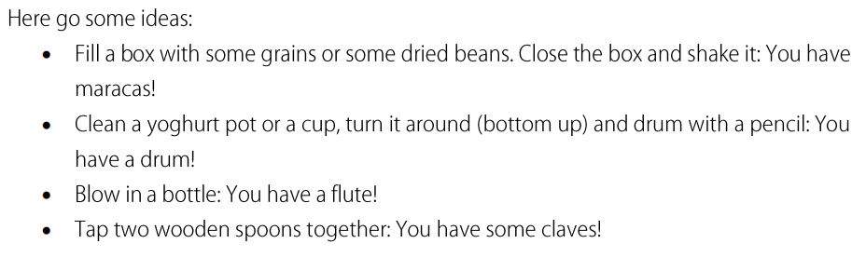
Can you think of anymore?
Task 3: Composing your own song
