Maths Starters Week 2 (27th April)
Thursday Starter- Roman Numerals
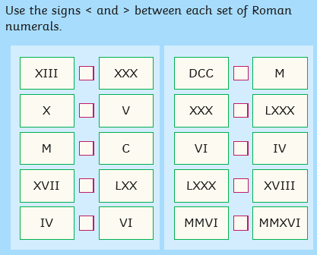
Friday Starter- Estimating answers
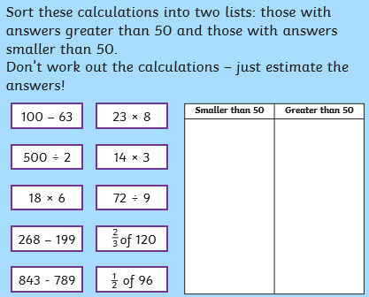
Now work out the answers and check if you were good at estimating!

Answers for Roman numerals:
