Maths- WB June 8th: Measures: Time
You are completing Week 4 lessons from Oak National Academy- Measures (Website: Type in Oak National Academy). Make sure you watch the lessons and follow the instructions as this week you are learning something new which you may find tricky. Most activities I have copied the tables for you to make it easier for you to complete the tasks.
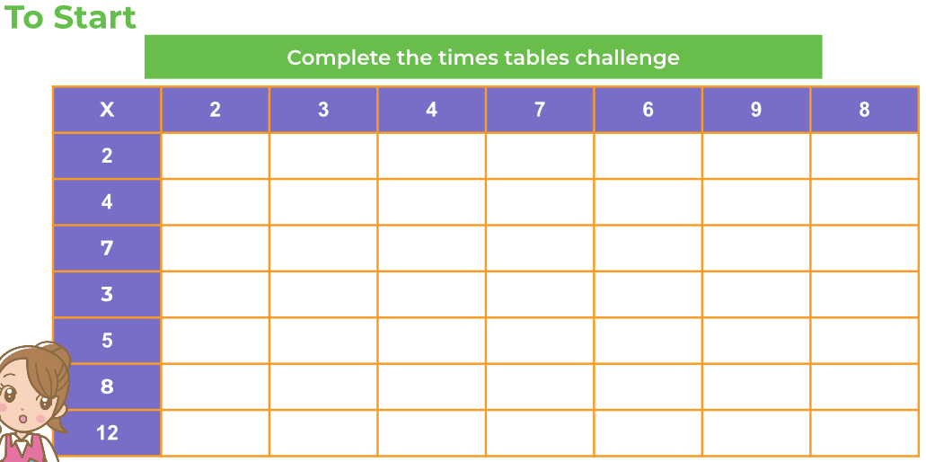
Monday 8th June-

Moving on in your books.
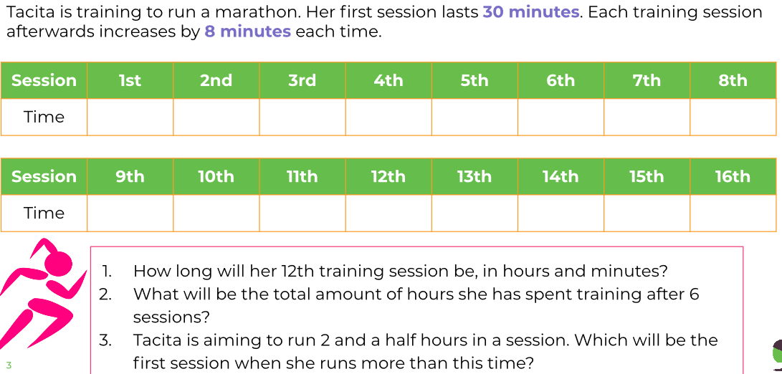
Attempt challenge in your books- try and draw your own table for Joe and Mary!

Tuesday 9th June
You should be able to complete all activities in your books.

Wednesday 10th June
To Start: Match the equivalent measures.
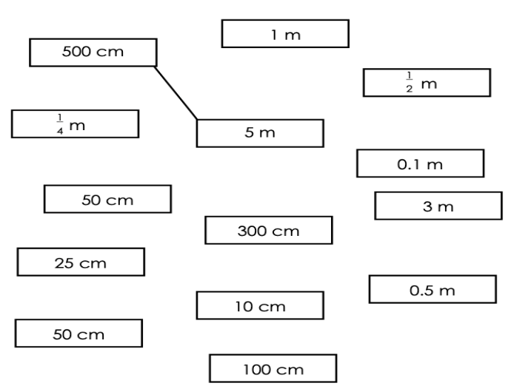

Draw the tables in your books and fill out.

Thursday 11th June

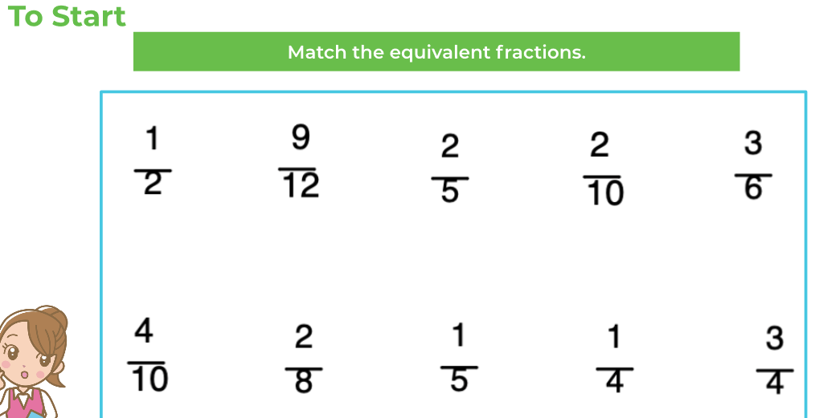
You will need to use your problem-solving skills to try and work this out! Try and use real coins if you can, it would really help.
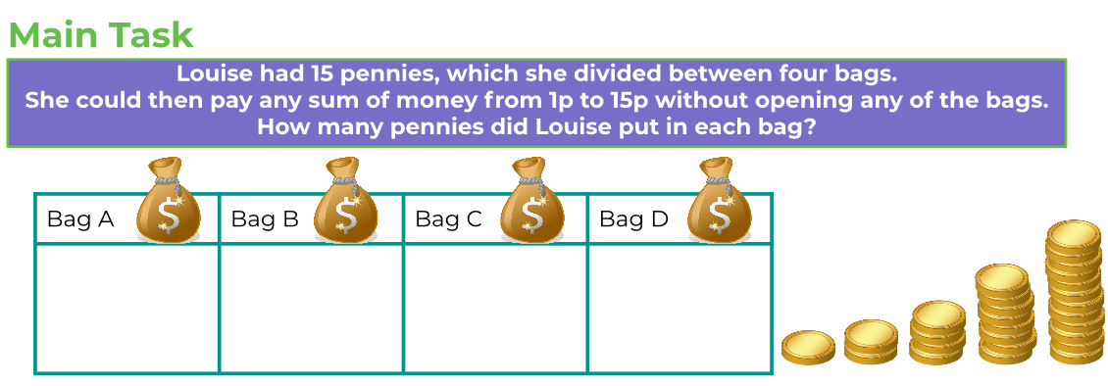
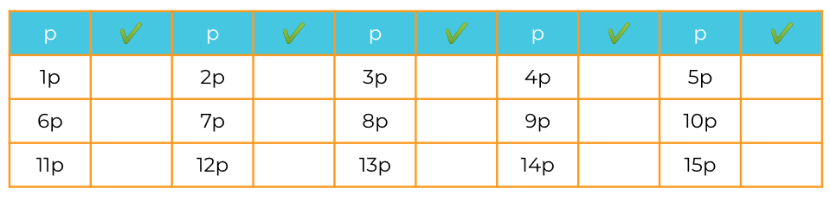
Complete challenge in your books.

Friday 12th June
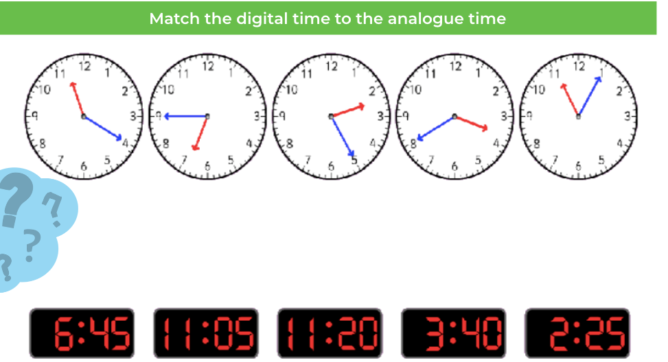
Write the answers to the word problems in your Maths books. Remember to write your answers in the real world in a sentence.
