Maths- WB June 29th Shapes Week 7 Oak Learning
You are completing Week 7 lessons from Oak National Academy (Website: Type in Oak National Academy). Make sure you watch the lessons and follow the instructions as this week you are learning something new which you may find tricky. I have copied less tables for you this week, so you may have to draw more tables/write more answers in your maths workbooks.
Monday 29th June-
Fill out grid based on the shapes you can see on the screen:
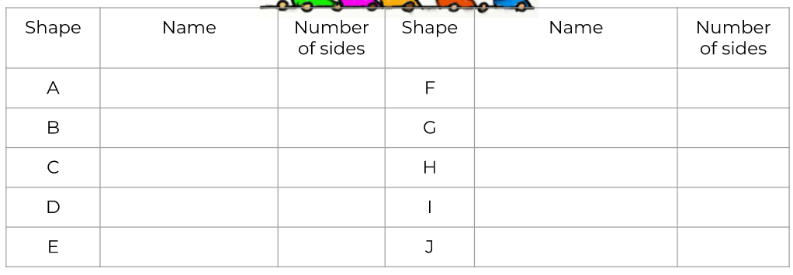
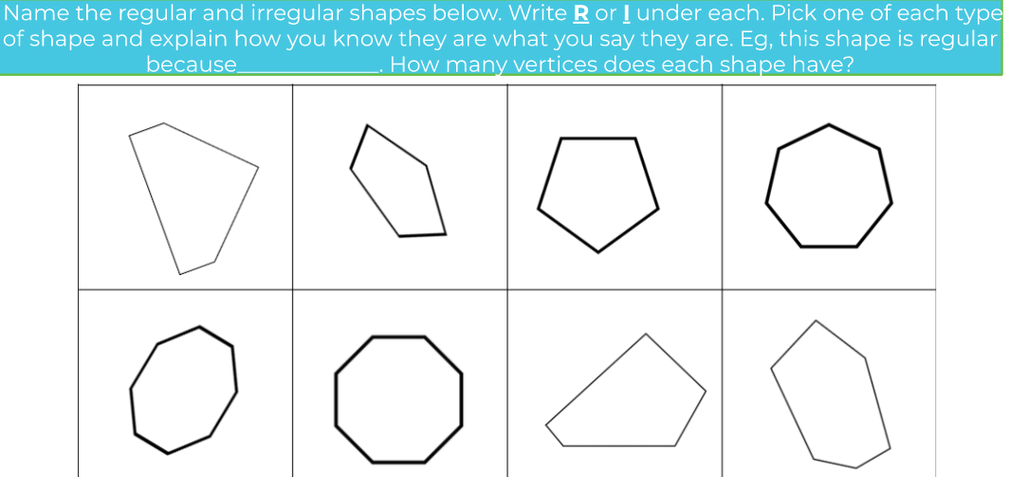

Tuesday 30th June
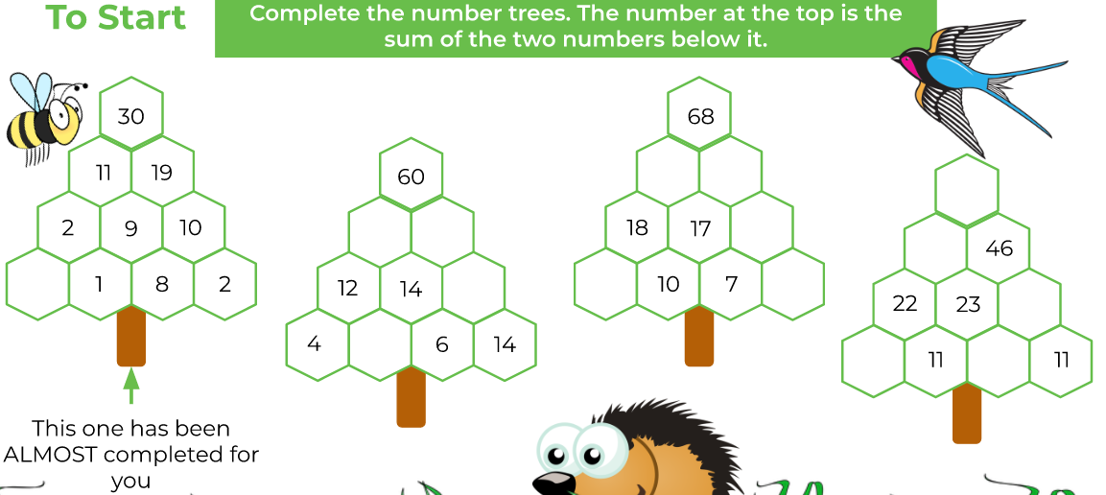
Complete the rest of the tasks for Tuesday in your books, use the squares in the book to help you draw.
Wednesday 1st July
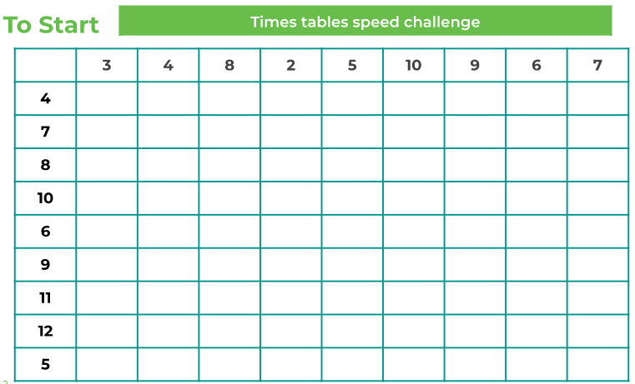
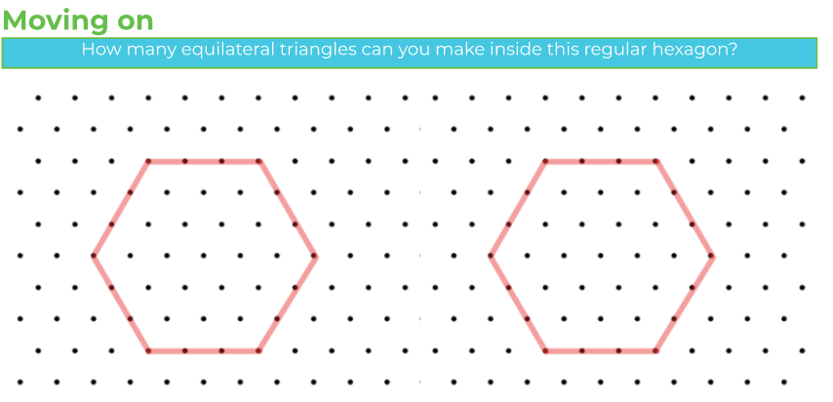
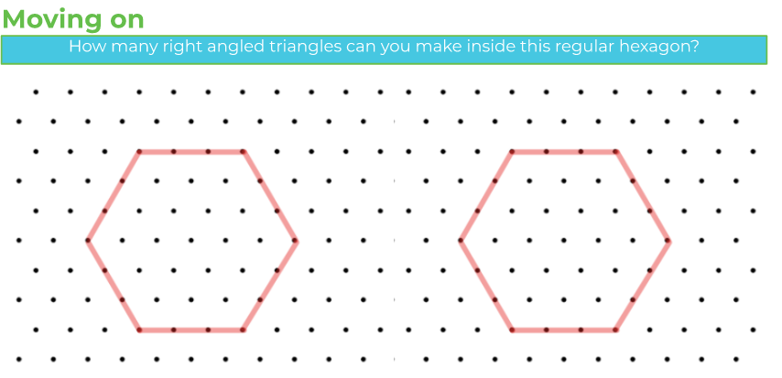
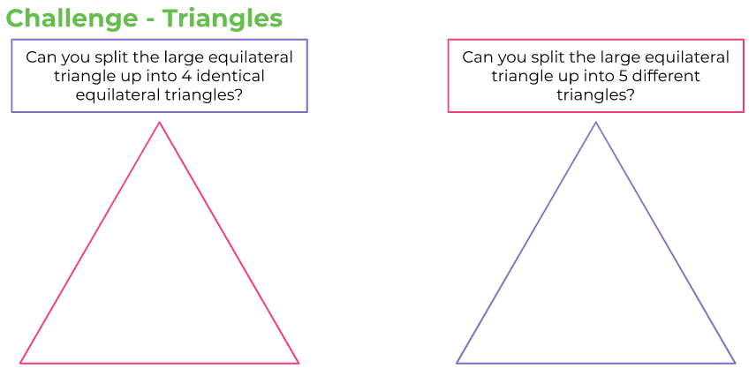
Thursday 2nd July
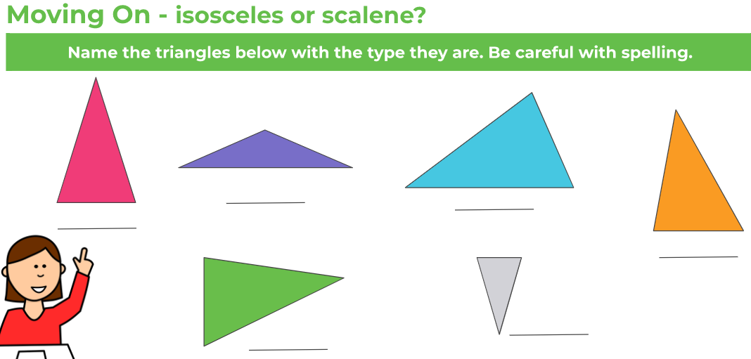
Draw the triangles in your books.

Friday 3rd July
Remember to READ the questions carefully so you know what you need to do.
