Maths- WB June 1st: Measures
You are completing Week 3 lessons from Oak National Academy- Measures (Website: Type in Oak National Academy). Make sure you watch the lessons and follow the instructions as this week you are learning something new which you may find tricky. Most activities I have copied the tables for you to make it easier for you to complete the tasks.
Monday 1st June-
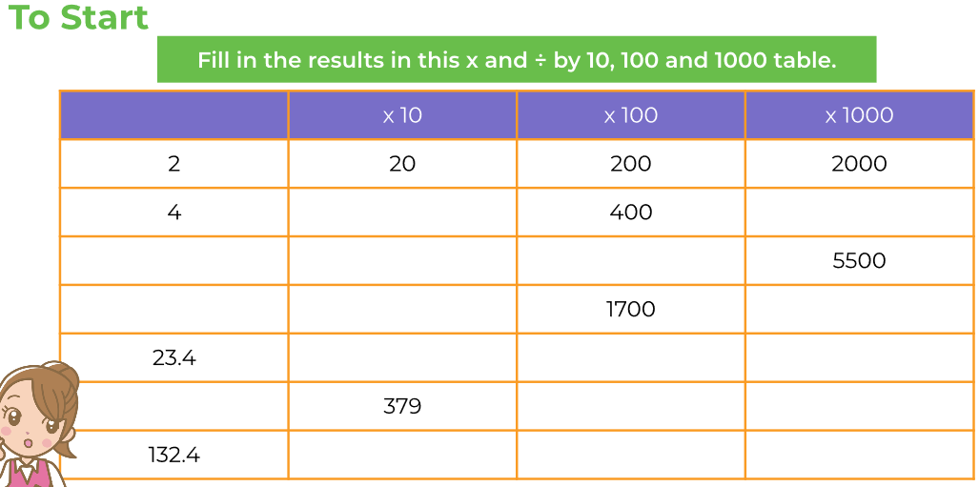
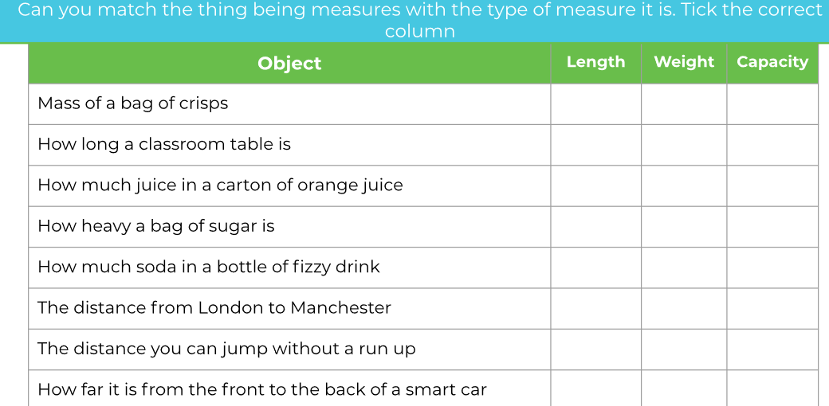
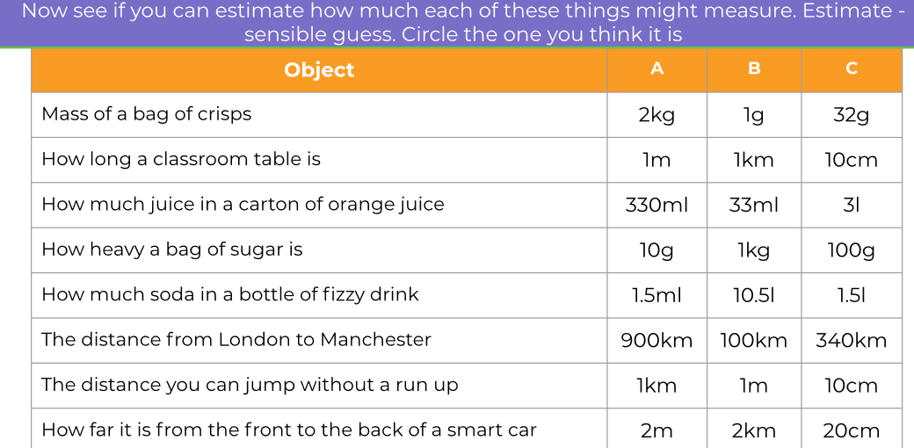
Attempt challenge in your books.

Tuesday 2nd June
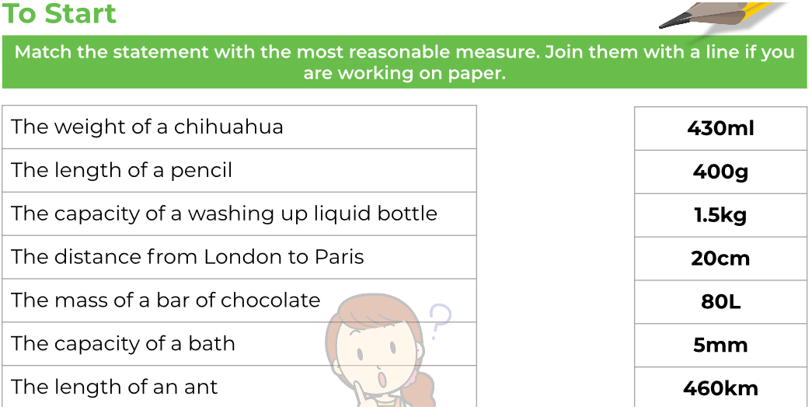
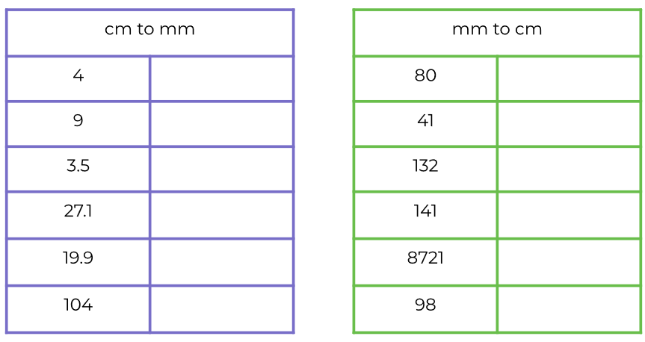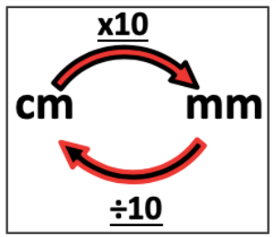
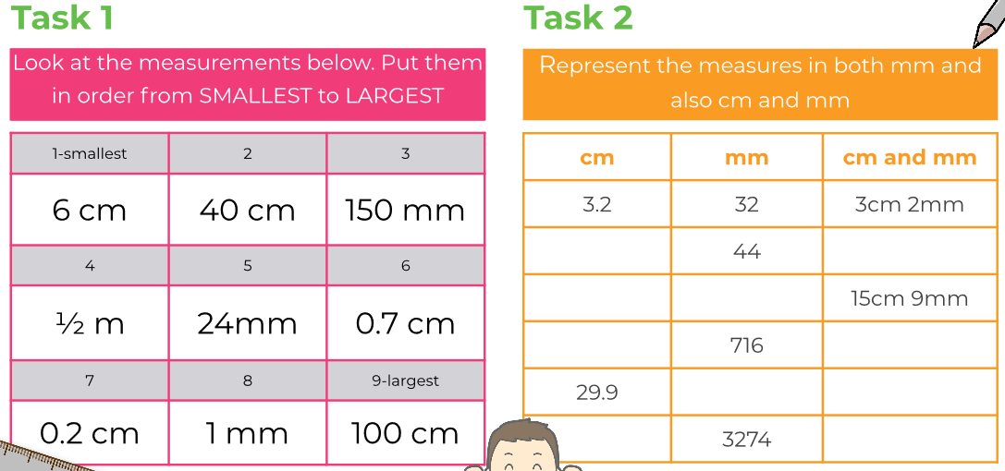

Attempt challenge in your books.

Wednesday 3rd June
To Start:
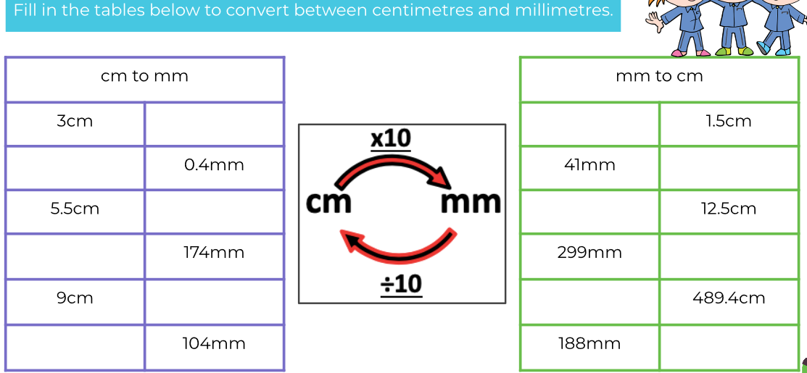
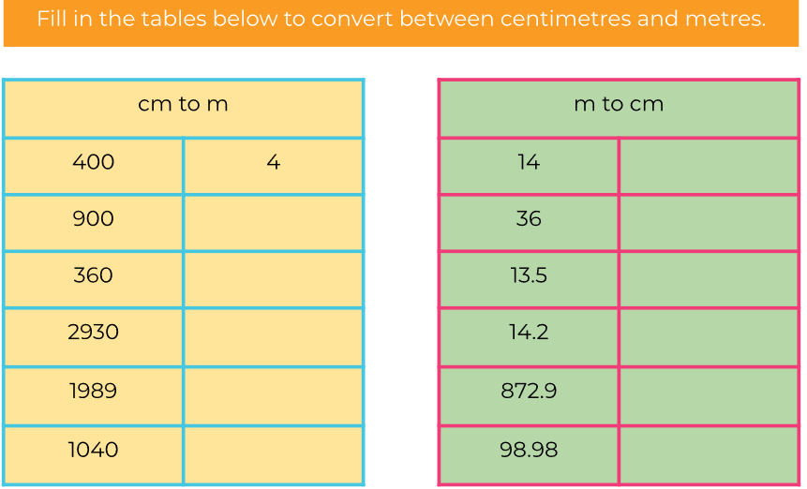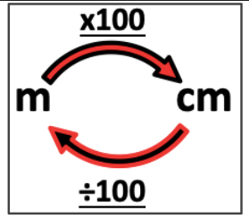
Task 1:
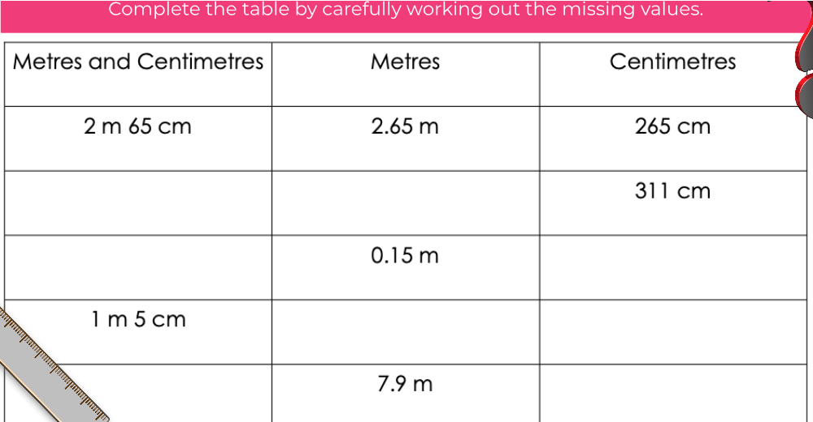
Complete task 2 in your books.

Thursday 4th June
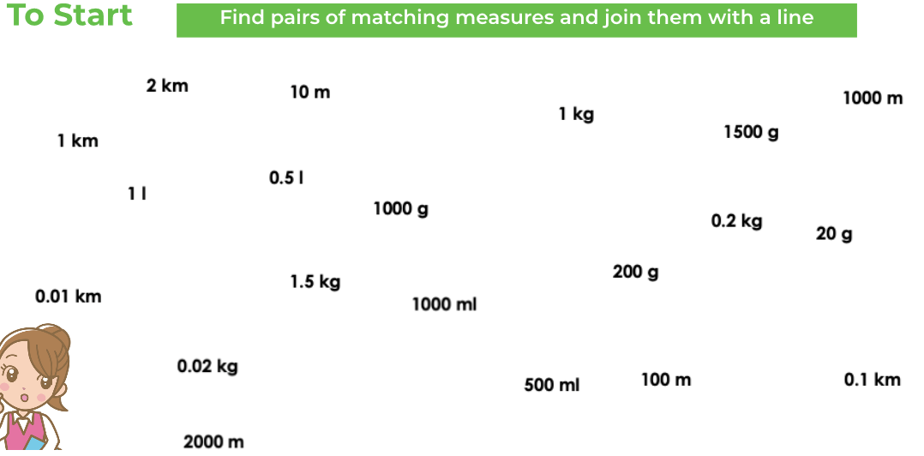
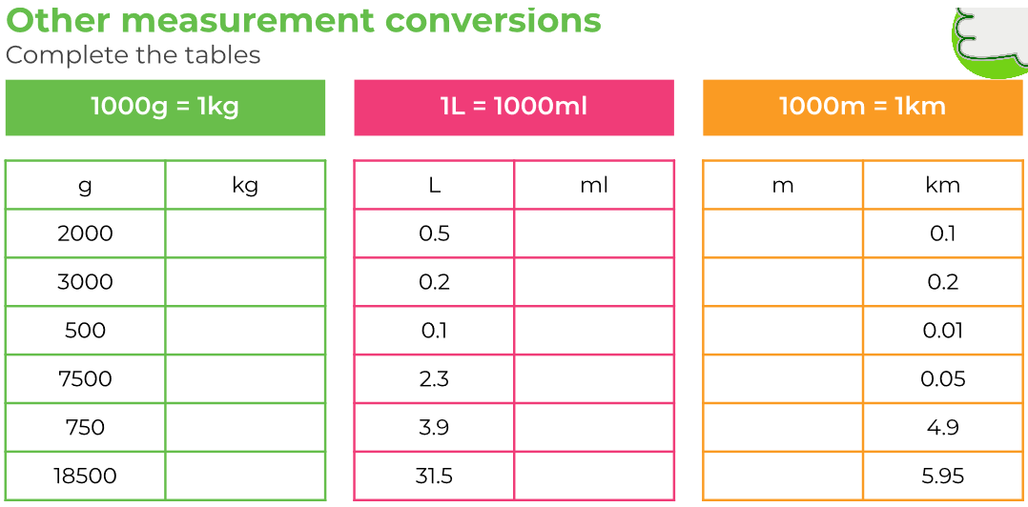
Task 2:
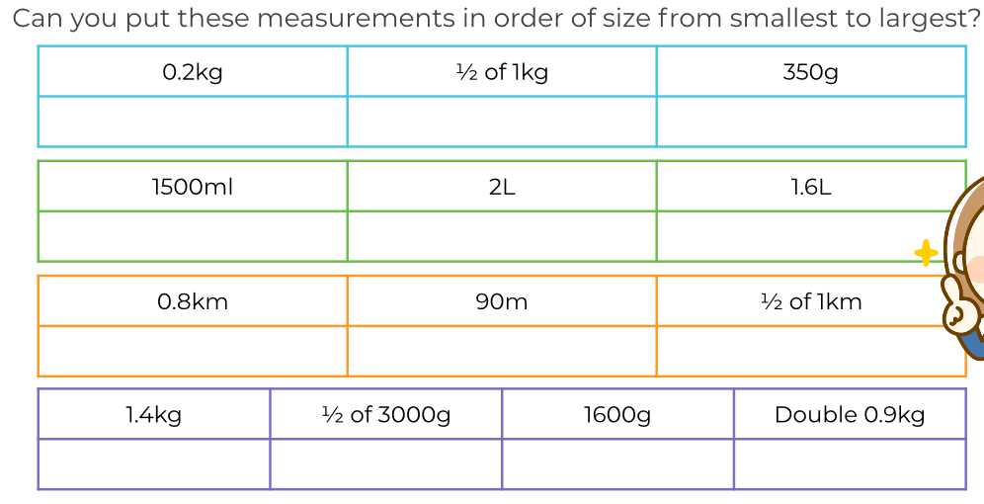

Friday 5th June
To start:
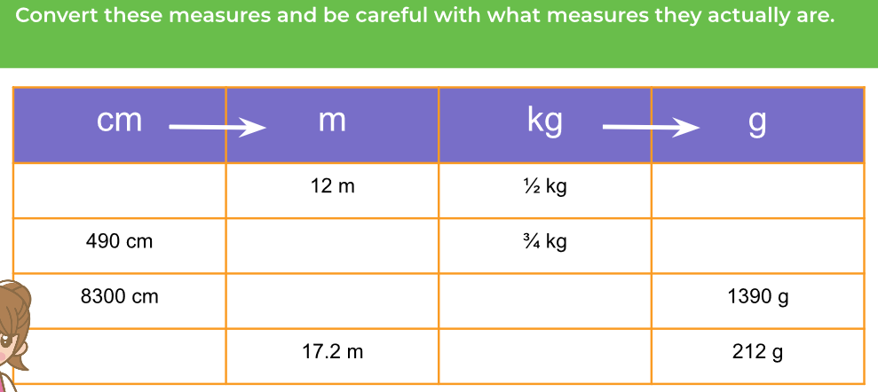

Write the answers to the word problems in your Maths books. Remember to write your answers in the real world in a sentence.

