Maths- WB June 15th Measures: Time
You are completing Week 5 lessons from Oak National Academy- Measures- weight, money (Website: Type in Oak National Academy). Make sure you watch the lessons and follow the instructions as this week you are learning something new which you may find tricky. I have copied less tables for you this week, so you may have to draw more tables/write more answers in your maths workbooks.
Monday 15th June-
Weight: Remember 1000g = 1kg
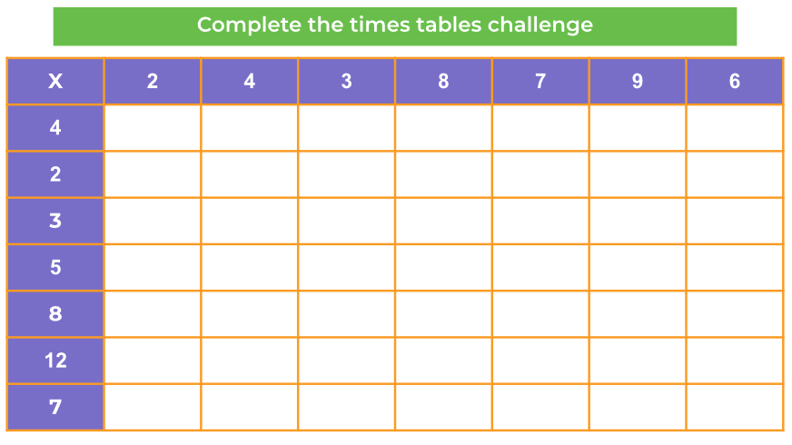
Tuesday 16th June
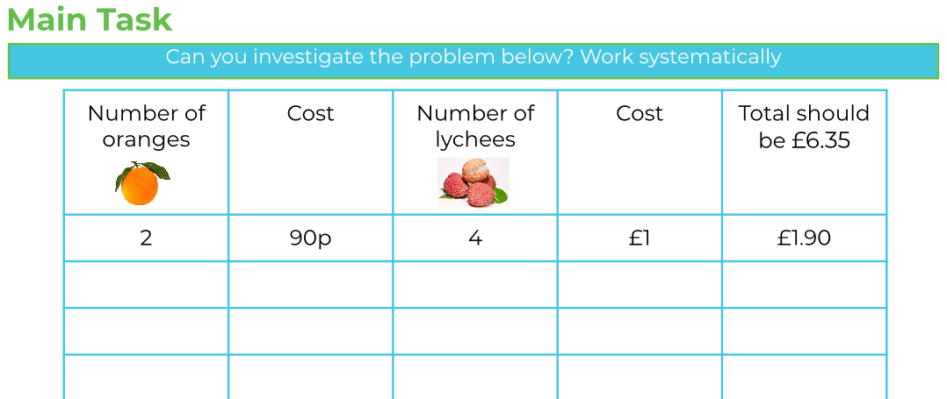
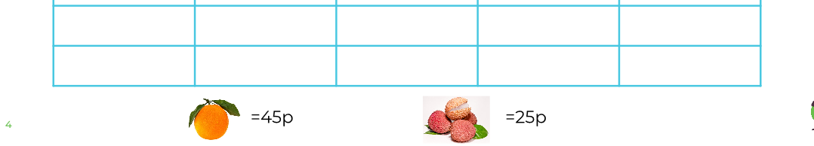
(How many oranges and lychees should be bought for the total to be £6.35)

Wednesday 17th June
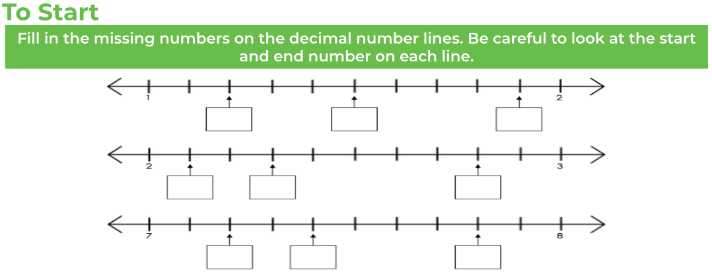
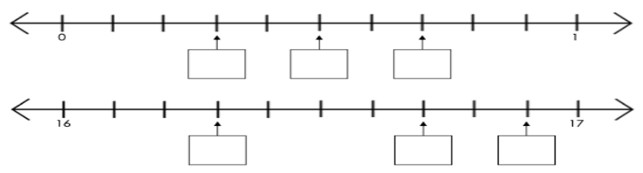
Draw out the table to solve the main task.
(Attempt challenge if you can)

Thursday 18th June

Draw a number line to help you solve the time questions in the ‘To start’.

Tip to help you with the rest of the activities:
1m = 100 cm
½ m = 50 cm
¼ m = 25 cm

Friday 19th June

(Remember sum means total)
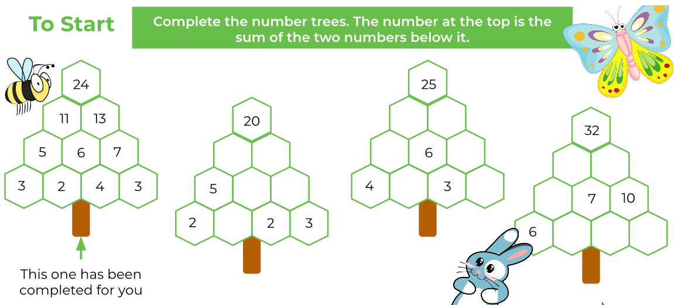

Remember to READ the questions carefully so you know what you need to do.

