Maths- WB 18th May: Area and Perimeter
Before you start the activities, you will need to complete the quiz and watch the video. Some activities you can complete in your new Maths books but some tables I have copied for you so you do not need to draw the table. You can cut and stick them in your book with the rest of the work from that day.

Monday-
To start:
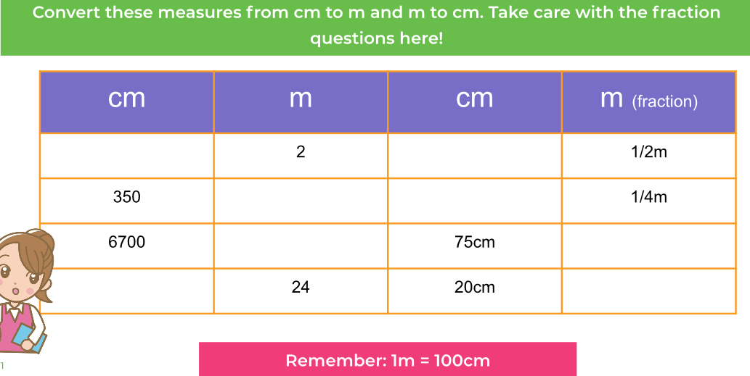

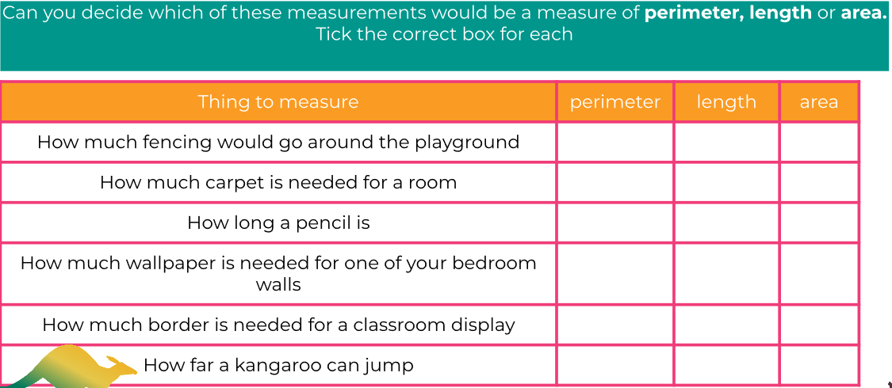

Complete main task in your book.

Tuesday
To start:
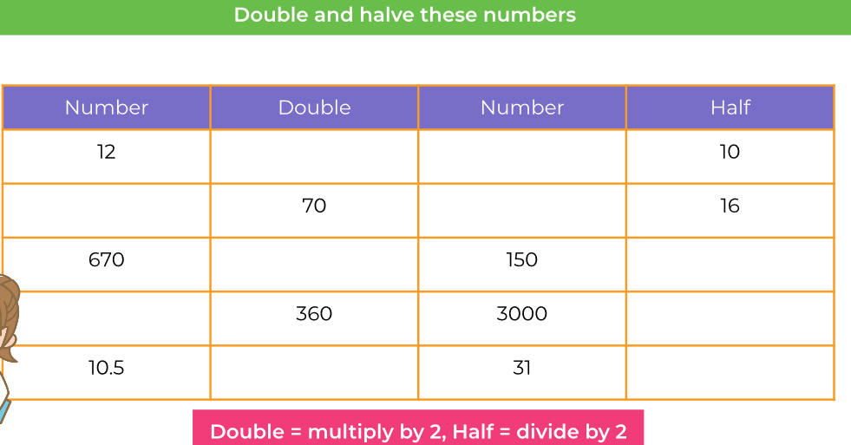
Calculate the areas of the shapes and fill in the table below.

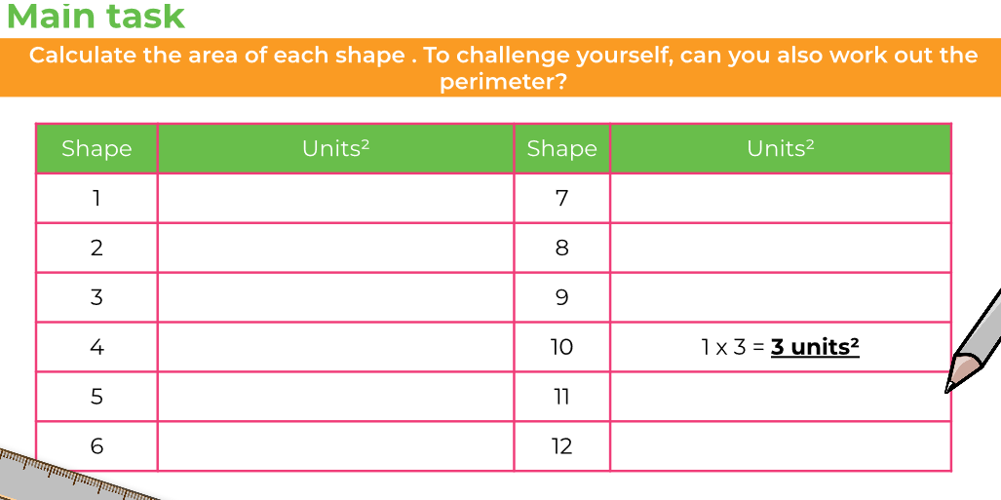

Wednesday

Complete ‘To Start’ and moving on in your books.

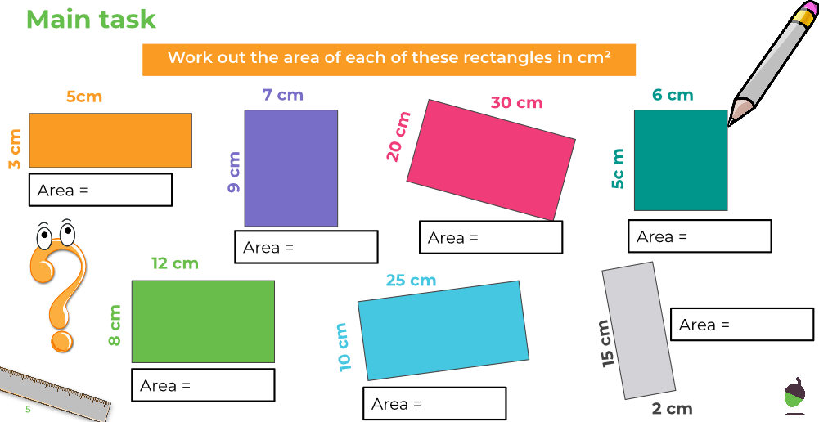

Thursday

Complete To start and Moving on in your books.
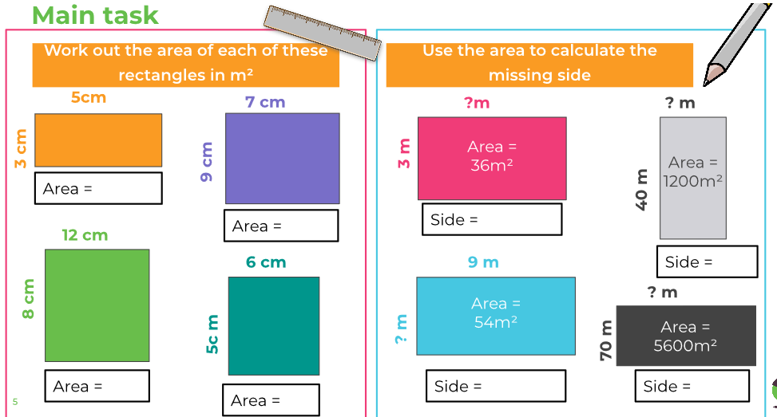

Friday
To start: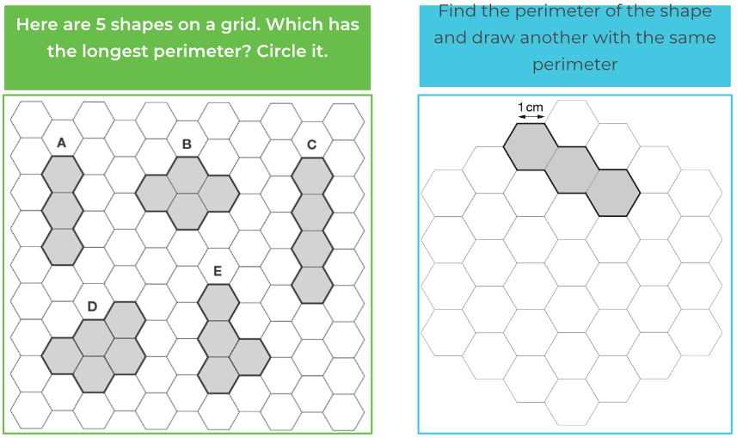

Complete the rest of the activities in your books.

