Maths- WB 8.6.20
Before you start the activities, you will need to complete the quiz and watch the video. Some activities you can complete in your new Maths books but some tables I have copied for you so you do not need to draw the table. You can cut and stick them in your book with the rest of the work from that day.

Monday- To convert miles and kilometres

Please follow the slides and complete the below task

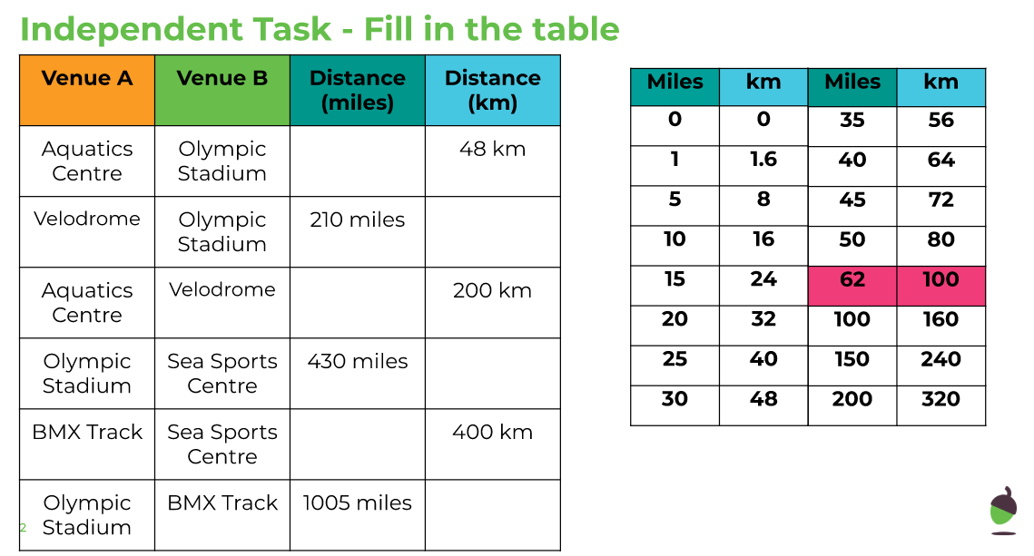

Tuesday – To convert between grams and kilograms

Please complete the independent task on slides 3, 4, 5 and 6

Wednesday – To convert units of mass

Please complete the independent task below

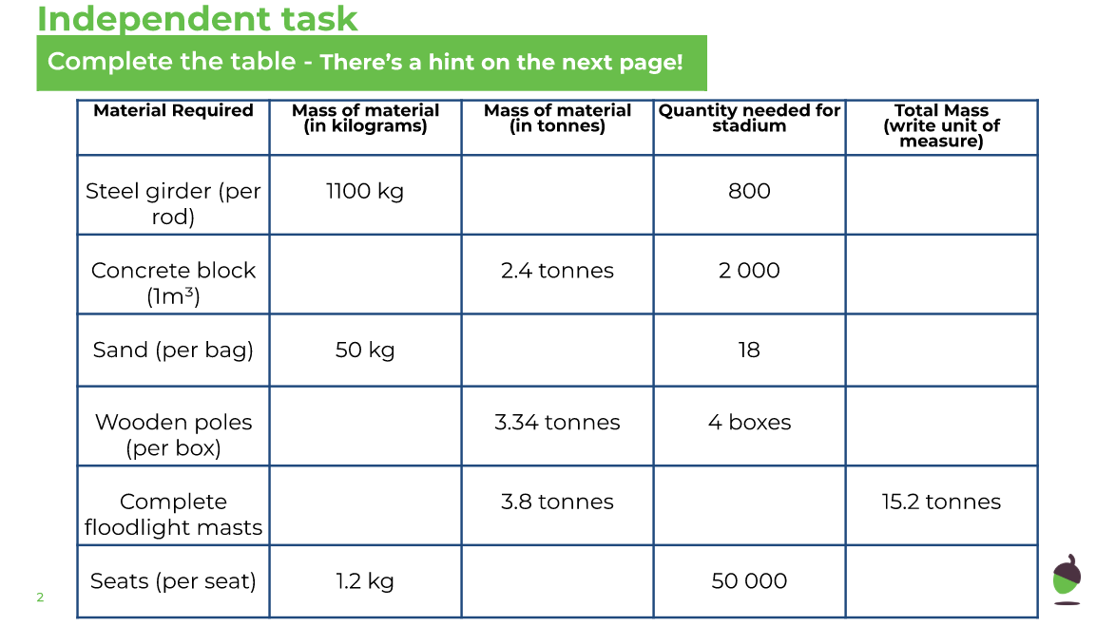

Thursday - To convert between pounds and kilograms

Please complete the independent task below

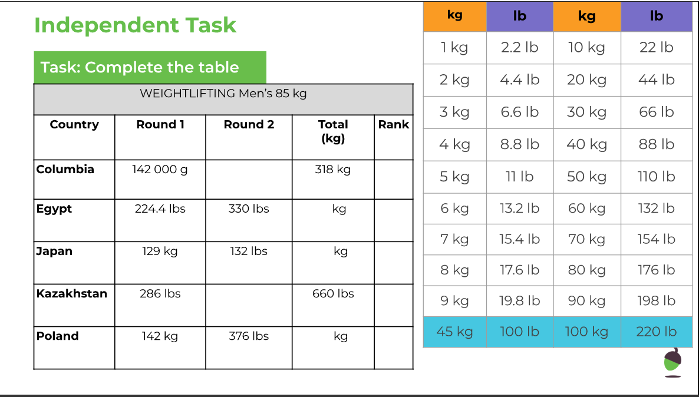

Friday - To apply measures and conversions in context

Please complete the independent task below

