Maths- WB 29.6.20
Before you start the activities, you will need to complete the quiz and watch the video. Some activities you can complete in your new Maths books but some tables I have copied for you so you do not need to draw the table. You can cut and stick them in your book with the rest of the work from that day.

Monday- To solve problems related to decimals

Please follow the slides and complete the independent tasks.

Tuesday – To investigate multiplying decimals

Please complete the questions in your exercise book.

Wednesday – To multiply decimals by whole numbers

Please complete the independent task in your exercise book. I have copied one of the tasks below.

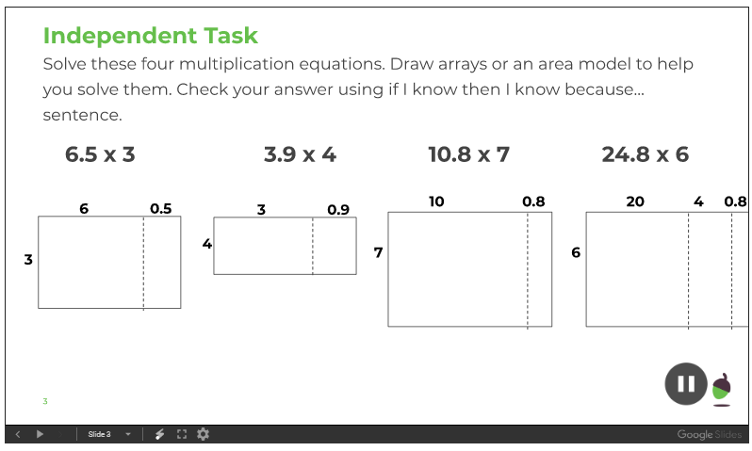

Thursday - To multiply decimals using a formal method

Please complete the independent task in to your exercise book.

Friday - To use a range of multiplication strategies

Please complete the independent task in to your exercise book.
I have copied the table below as it may help you with your presentation.

