Maths- WB 22.6.20
Before you start the activities, you will need to complete the quiz and watch the video. Some activities you can complete in your new Maths books but some tables I have copied for you so you do not need to draw the table. You can cut and stick them in your book with the rest of the work from that day.

Monday- Decimals: To represent decimals

Please follow the slides and complete the below tasks.

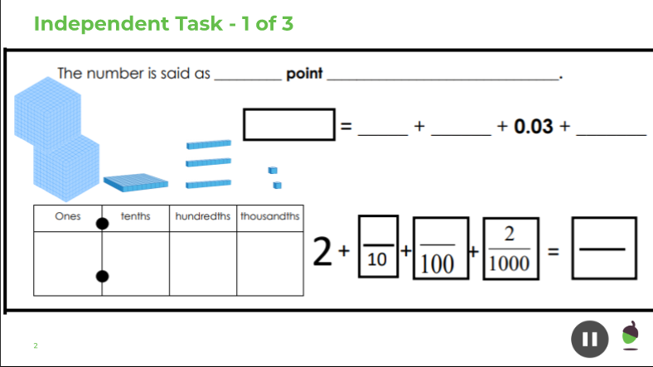

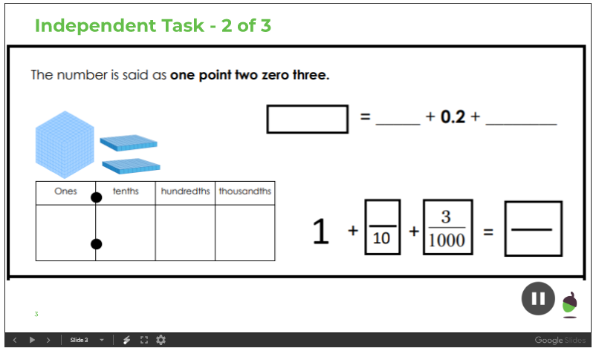

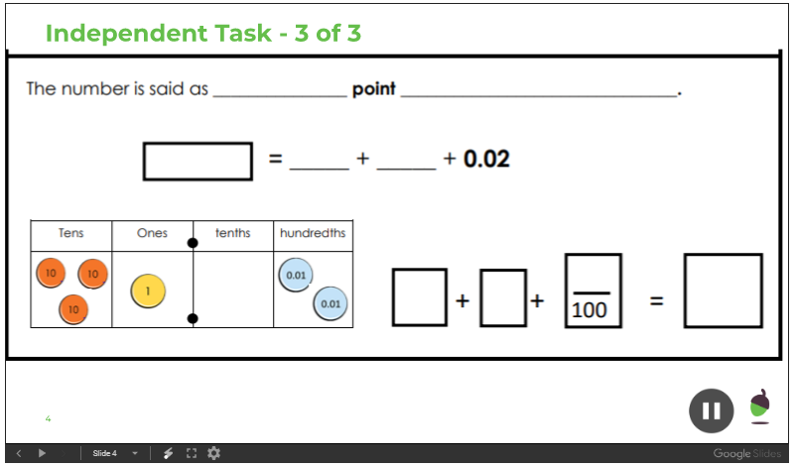

Tuesday –Decimals: To represent multiplication and division by 10, 100 and 1000.

Please complete the questions 1 to 4 in your exercise book.

Wednesday – Decimals: To derive addition and subtract decimal facts.

Please complete the independent task below
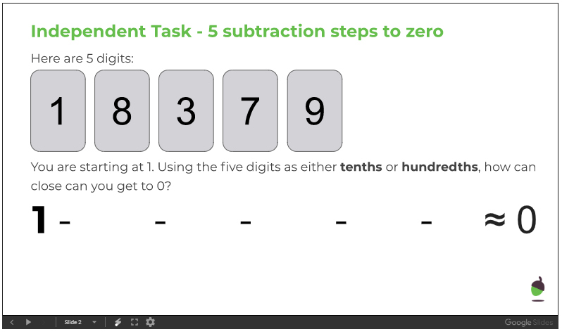

Thursday - Decimals: To add decimal numbers

Please complete the independent task in to your exercise book.

Friday - Decimals: To subtract decimal numbers

Please complete the independent task in to your exercise book.

