Maths- WB 11th May:
Before you start the activities, you will need to complete the quiz and watch the video. Some activities you can complete in your new Maths books but some tables I have copied for you so you do not need to draw the table. You can cut and stick them in your book with the rest of the work from that day.

Monday-
To identify and describe reflections

Please find a copy of the independent task below.

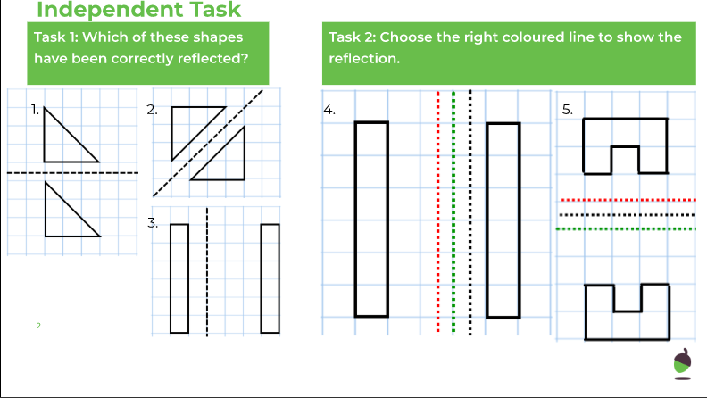

Tuesday –
To describe reflections using coordinates

Please find a copy of the independent task below.

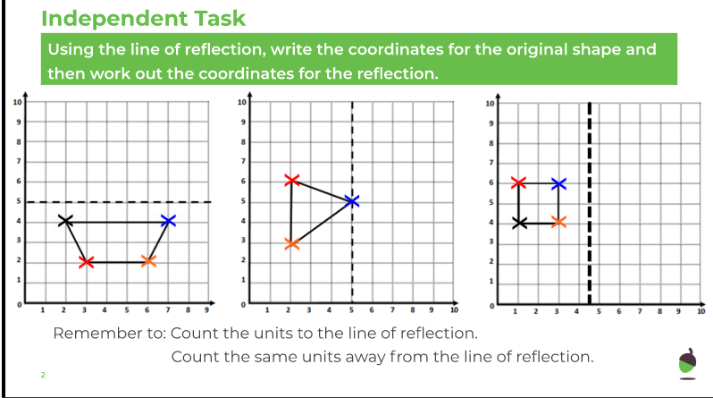

Wednesday –
To reflect shapes along axes

Please find a copy of the independent task below.

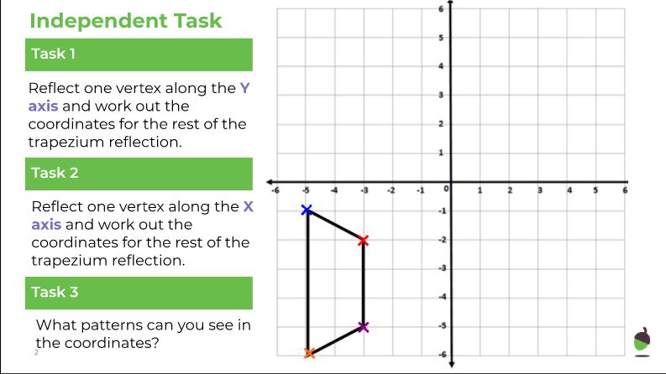

Thursday -
To reason about reflection

Please find a copy of the independent task below.

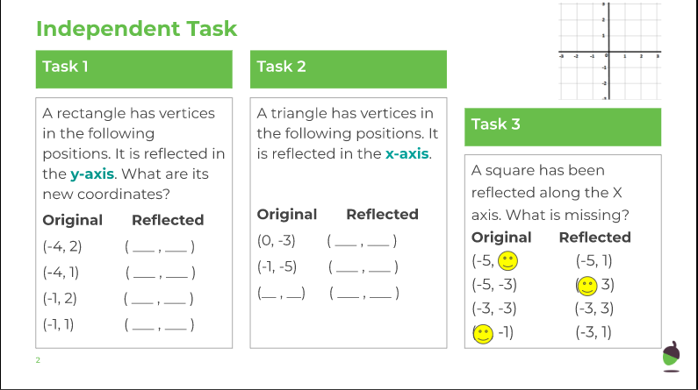

Friday - To make links between reflections and translations.

Please find a copy of the independent task below.

