Maths- WB 15.6.20

Before you start the activities, you will need to complete the quiz and watch the video. Some activities you can complete in your new Maths books but some tables I have copied for you so you do not need to draw the table. You can cut and stick them in your book with the rest of the work from that day.

Monday- Volume: To read scales when measuring volume

- Complete the independent task and questions in your exercise book.

Tuesday – Volume: To investigate and explain cubed numbers

- I have copied the table below so you can complete it straight on to this sheet.

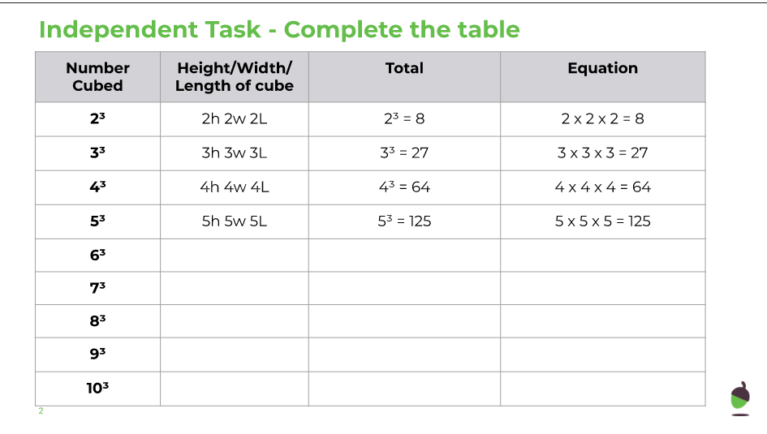

Wednesday – Volume: To estimate the volume of objects

- Complete the independent task and questions in your exercise book.

Thursday - Volume: To describe volume in cubic units

- Complete the independent task and questions in your exercise book.

Friday - Volume: To convert units of volume

- Complete the independent task and questions in your exercise book.

