Maths- WB 1.6.20
Before you start the activities, you will need to complete the quiz and watch the video. Some activities you can complete in your new Maths books but some tables I have copied for you so you do not need to draw the table. You can cut and stick them in your book with the rest of the work from that day.

Monday- To convert between seconds, minutes and hours

Please follow the slides and complete questions 1 to 3 in your exercise books.

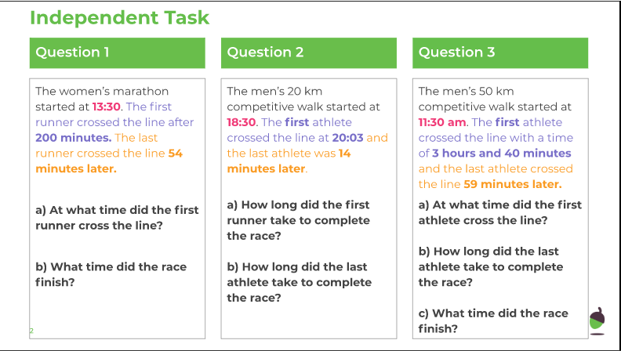

Tuesday – To solve problems involving converting between hours and minutes

Please find a copy of the independent task below.

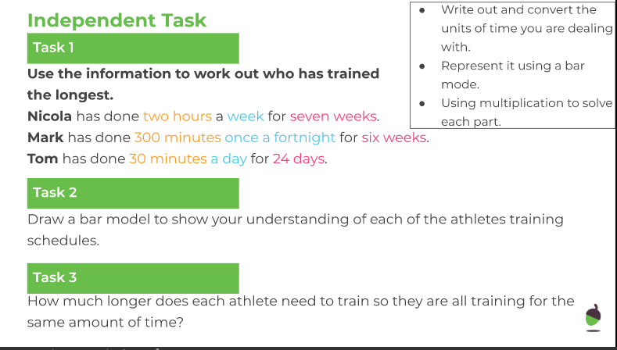

Wednesday – To convert between units of length

Please find a copy of the independent task below.

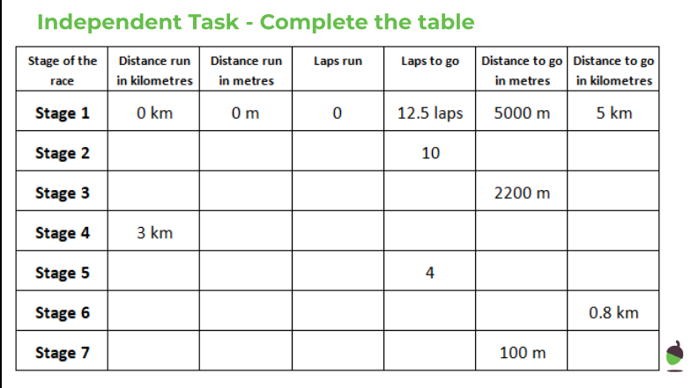

Thursday - To apply length conversions to problems

Please find a copy of the independent task below.

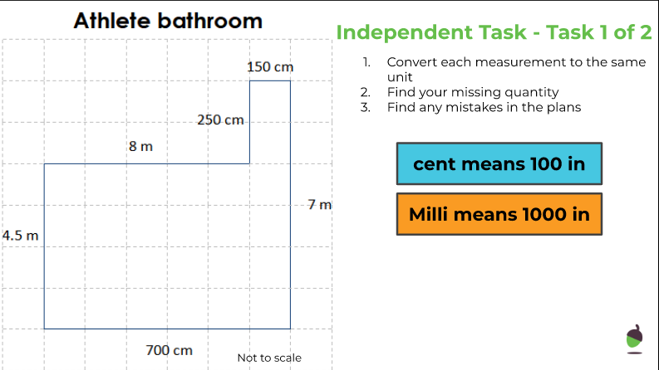

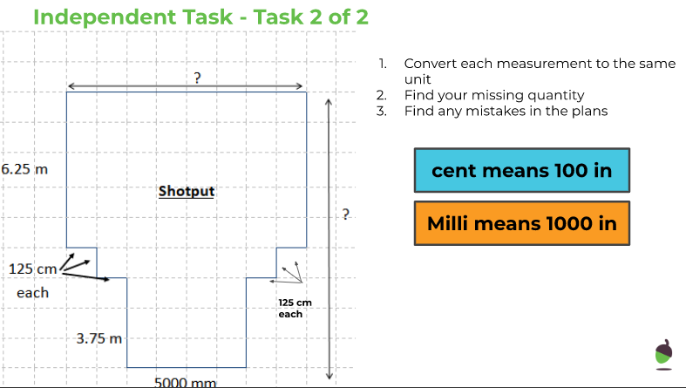

Friday - To find the perimeter and convert units of measurements

Please find a copy of the independent task below.

