Maths- WB 11th May: Area and Perimeter
Before you start the activities, you will need to complete the quiz and watch the video. Some activities you can complete in your new Maths books but some tables I have copied for you so you do not need to draw the table. You can cut and stick them in your book with the rest of the work from that day.

Monday-
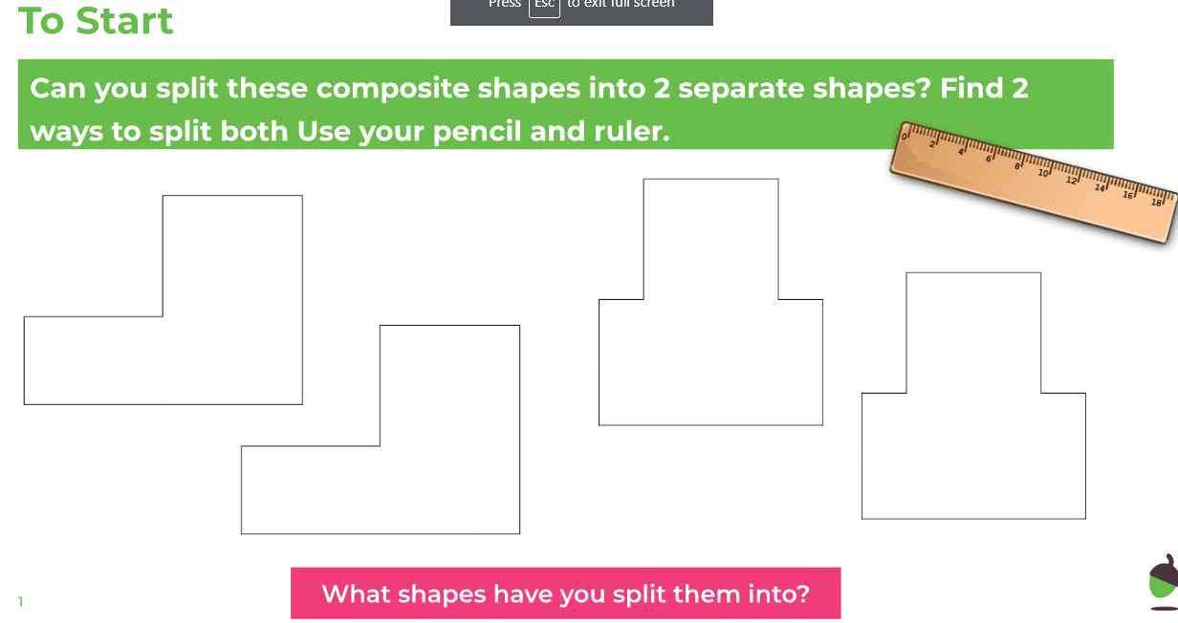

Complete other activities and attempt challenge in your Maths books.

Tuesday

Draw the shapes in your books. You have squares in your Maths books.
Attempt challenge.

Wednesday

Complete ‘To Start’ in your books.
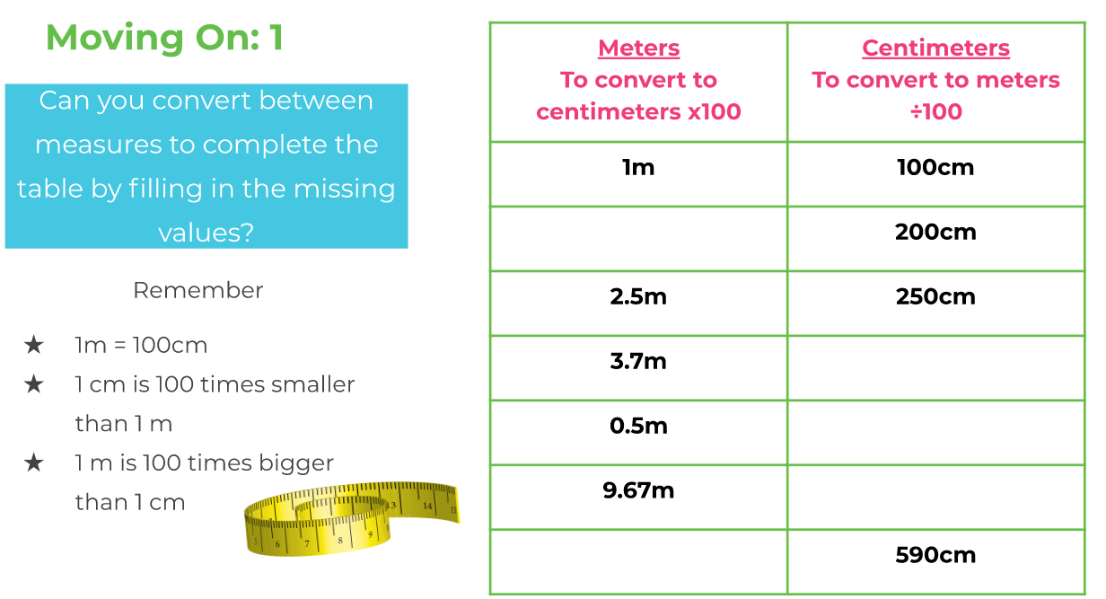
Complete other activities and attempt challenge in your Maths books.

Thursday

(The activity online is the same as Monday)
Complete TTRS.
Go online on Sumdog and TTRS and practice.

Friday

Complete all activities in your book.
Attempt the challenge.

