LITERACY week beginning 15.6.2020
This week you will be thinking about some different kinds of magic boxes.
Monday 15th June 2020 LI: To design a book cover
Re-read the story of Pandora’s Box:
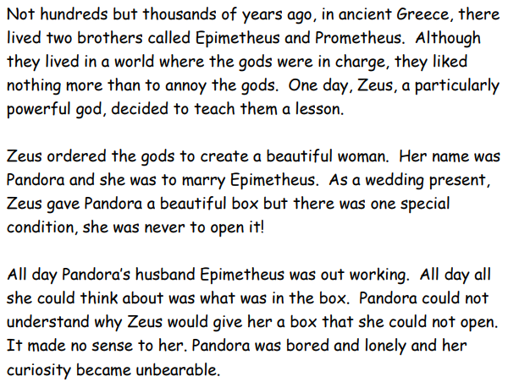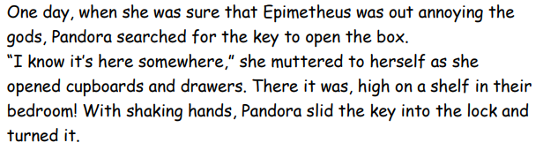
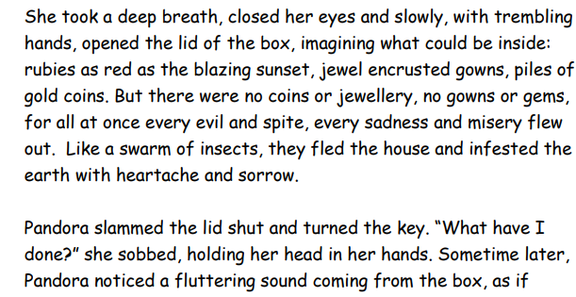
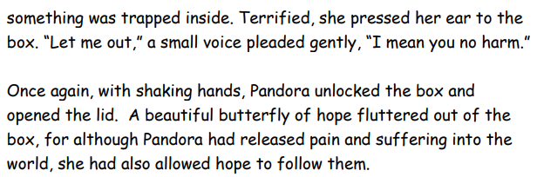

Think about what happens in this story and use what you know to design a front cover and a back cover for the book of Pandora’s Box.
On the back cover, include a blurb explaining what the story is about.

Front cover | Back cover  Blurb: This story is all about  _________________________  _________________________  _________________________  _________________________  _________________________  You will enjoy this story because  _________________________  _________________________  _________________________  _________________________

Tuesday 16th June 2020 LI: To use apostrophes

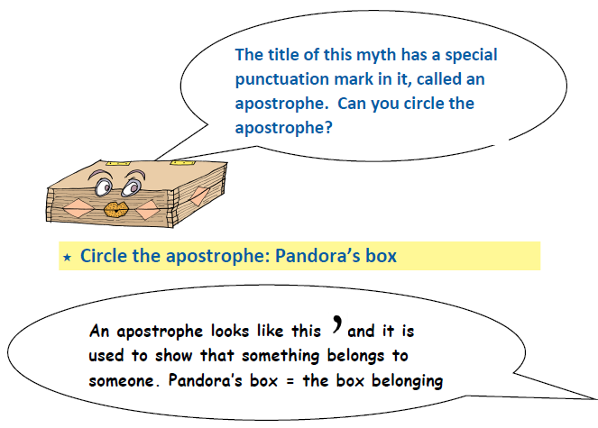
The box belonging to
Pandora
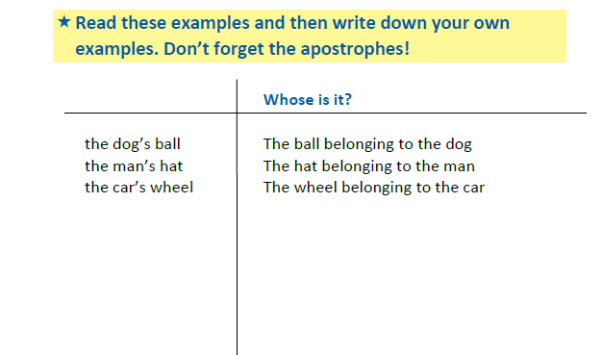

Wednesday 17th June 2020 LI: To read and think about a poem
Pandora’s Box was about a magical box, but there are other kinds of magic boxes! Read this poem The Magic Box by Kit Wright
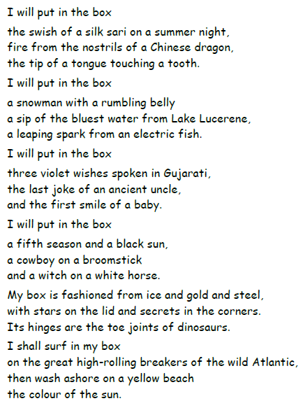

If you have a computer, you can listen to Kit reading his poem by putting this address into the internet:
https://www.bbc.co.uk/bitesize/clips/zkpmhyc

Then think about the poem and write your ideas here:
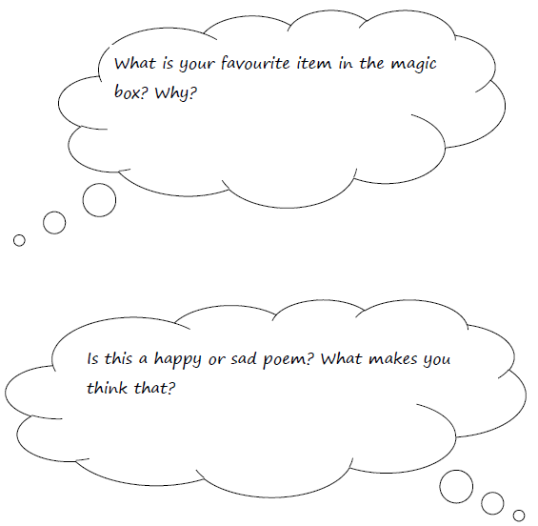

Thursday 19th June 2020 LI: To make a magic box
Now make your own magic box

You can:
➢ Find a shoe box or small box and decorate it OR
➢ Draw a box and decorate it

Think about:
• Choose an idea for your box. Perhaps you could decorate it with the things, people or places that are special or magical to you.
Or maybe it is a magical creatures box or a box from a magical place.
• How you can make it magical? Perhaps it has eyes. Maybe it looks like a dragon, a witch’s house or a King’s castle. What magical things could be inside the box? What might happen when you open the box?
• Is the lid attached to the box or does it lift off completely?

Here are some ideas:
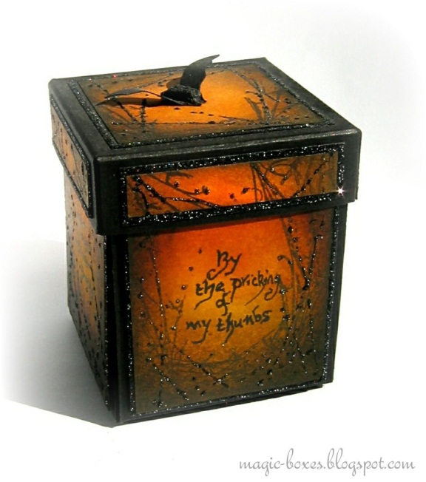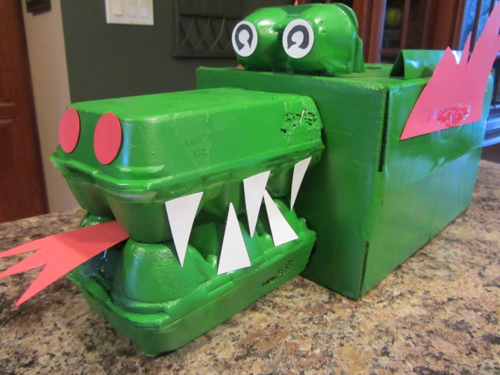

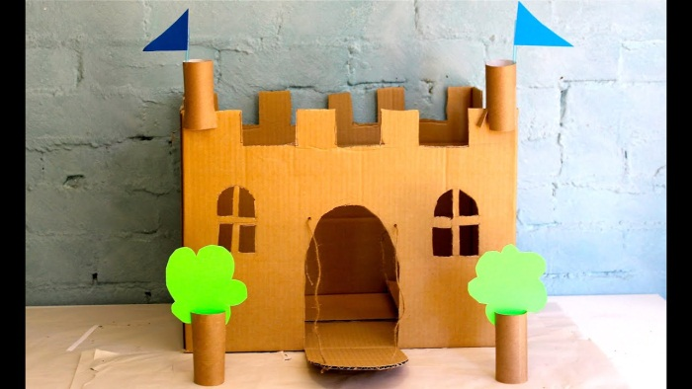

Friday 20th June 2020 LI: To write a magic box poem
Think about what things, people or places are special or magical for you.
You are going to use these ideas to write your own magic box poem.
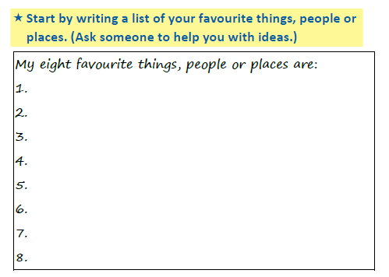
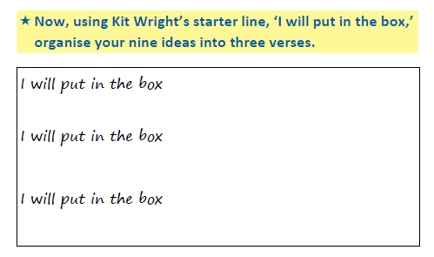
Now think about the end part of your poem.
Try to describe:
- what your box is made from,
- what the lid is like
- what secrets are in the corners
Make your ideas as strange and magical as you like!

Here is the end of Kit Wright’s poem…
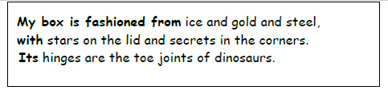

Write the end of your poem here:

Monday 15th June 2020 Handwriting

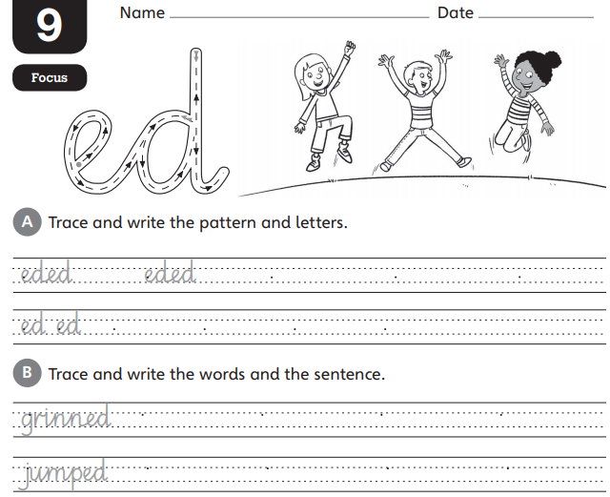
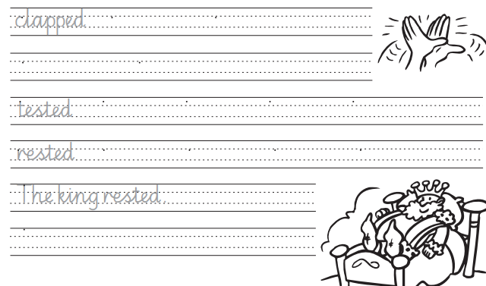

Tuesday 16th June 2020 Handwriting
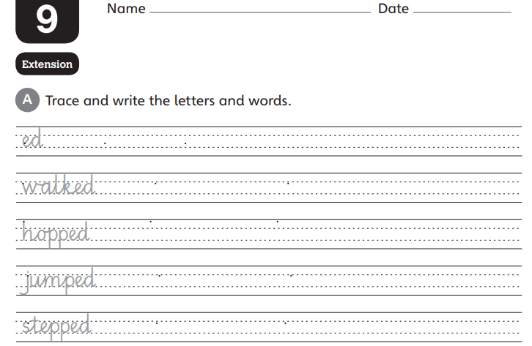

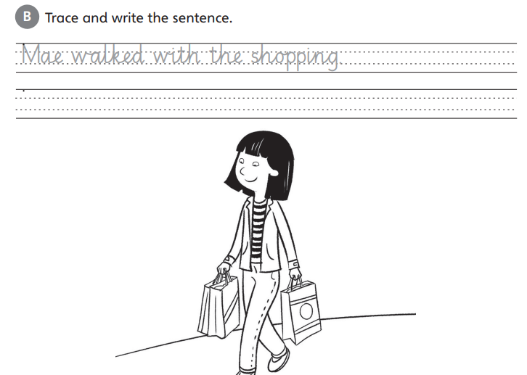

Wednesday 17th June 2020 Spelling
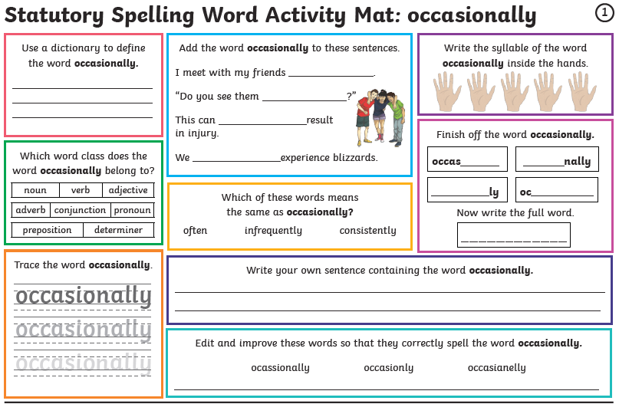
Thursday 18th June 2020 Spelling
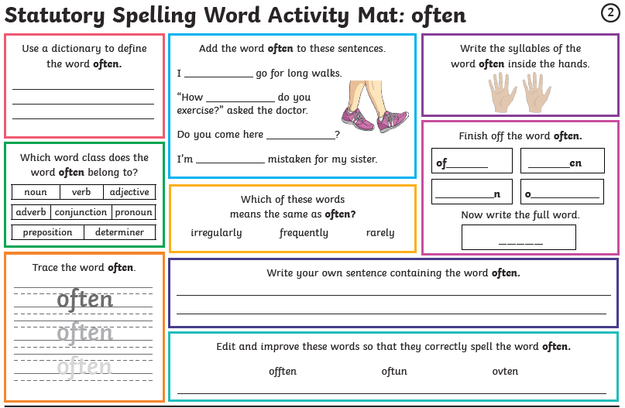
Friday 19th June 2020 Spelling
