LITERACY week beginning 8.6.2020
This week you will be reading Pandora’s Box and doing some activities based on the story.
Monday 8th June 2020 LI: To describe
The story of Pandora’s Box is a myth from the country of Greece, which people have been telling for thousands of years. Read the first part of the story then do the activity.
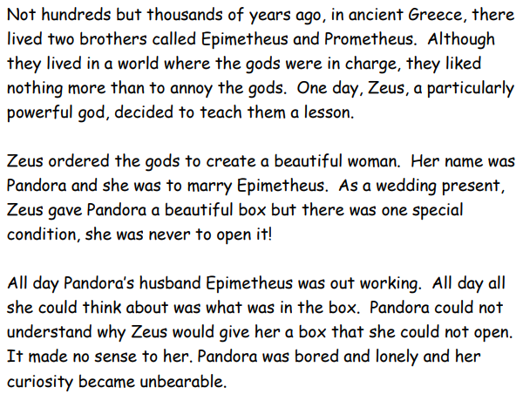
What do you think the box looked like? Draw it here:

Now describe the box in detail. Think about size, colour and shape. Was it shiny and new or old and dusty? Brightly coloured or dull and plain? What did the lock or handle look like?
The box was ______________________________________________________________________________________________________________________

Tuesday 9th June 2020 LI: To predict
Read the next part of the Pandora story and do the activites
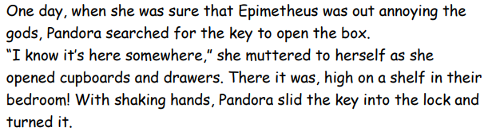
Now stop and draw what you think will be inside the box:

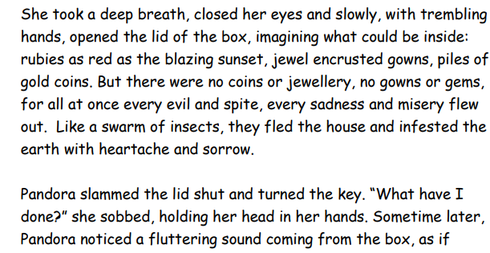
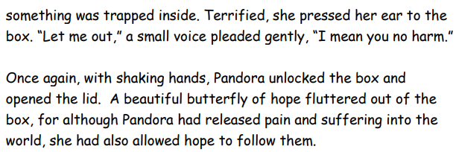

Next draw what you think the evil things or the butterfly of hope looked like:

Wednesday 9th June 2020 LI: To share my thoughts about a story

Re-read the whole story and record your thoughts in a ‘Tell Me’ grid below
What I liked about the story | What I didn’t like about the story
Questions that I’m wondering about the story | Things that the story reminded me of

Now answer these questions about the story:

When did the story happen?______________________________

Who was in charge of the Ancient Greek world?_____________

Who gave Pandora the box?______________________________

Do you think Pandora should have opened the box? Why?
Why not?____________________________________________
________________________________________________________________________________________________________
Did you like the end of the story? Why? / Why not?____________________________________________________________________________________________________

Thursday 10th June 2020 LI: To understand words in a story
Here are some words from the story. Try to match the words to their meanings. Use a dictionary or an internet search to help you (do a google search to find the meaning – to find the meaning of powerful you could search for ‘powerful meaning’)
Try to match as many as you can but don’t worry if you can’t find them all.
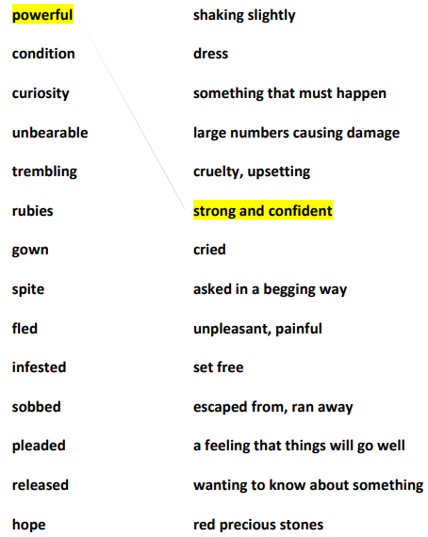
Now look at some words in sentences. For each word, write a new sentence of your own:

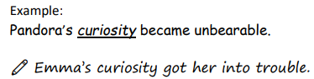

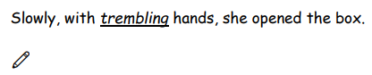
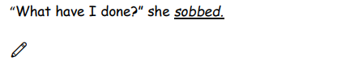
Friday 11th June 2020 LI: To map a story

Re-read the whole story again and think about the four main things that happen.
Create a story map showing the four main parts of the story in pictures and words.
Try to include the words: trembling sobbed curious

1 Draw | 2 Draw
Write | Write
3 Draw | 4 Draw
Write | Write

Monday 8th June 2020 Handwriting
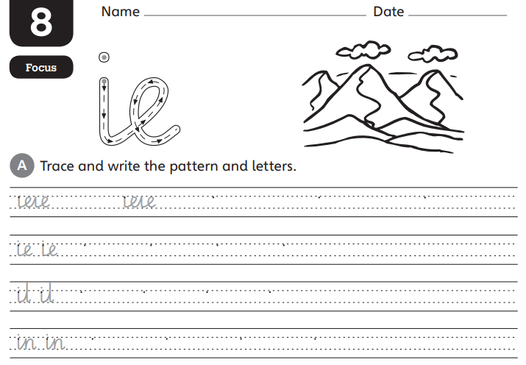
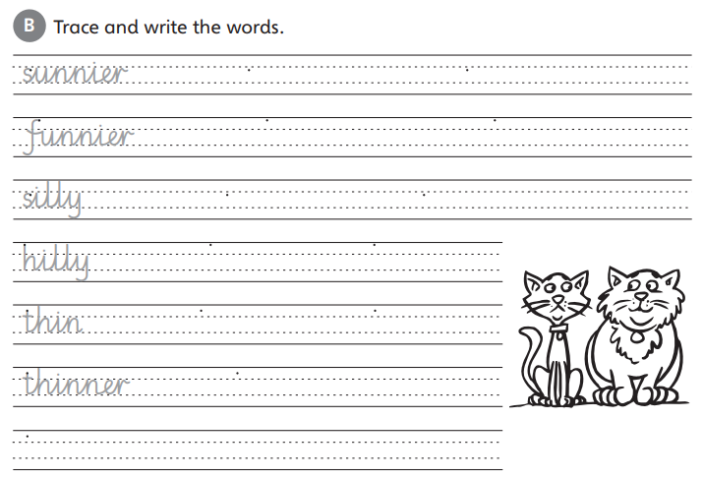

Tuesday 9th June 2020 Handwriting
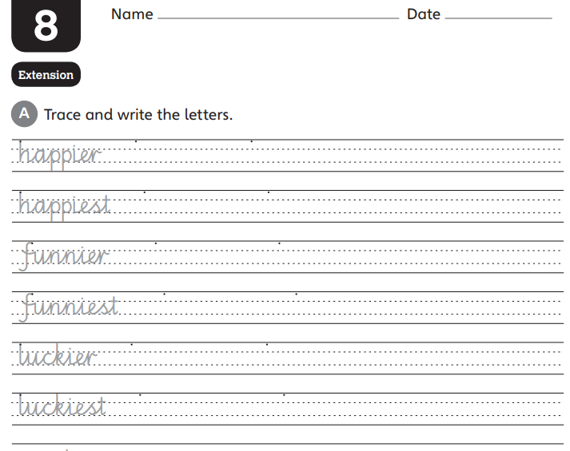
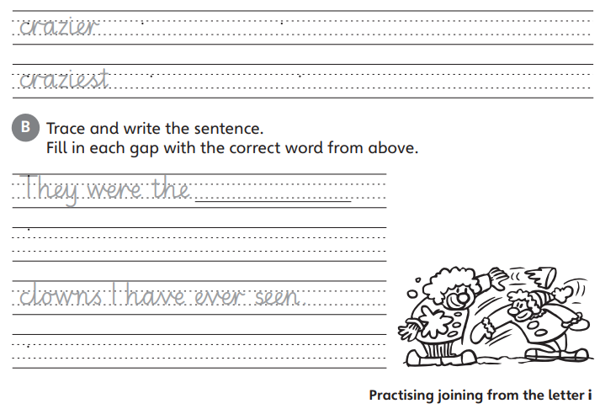

Wednesday 10th June Spelling
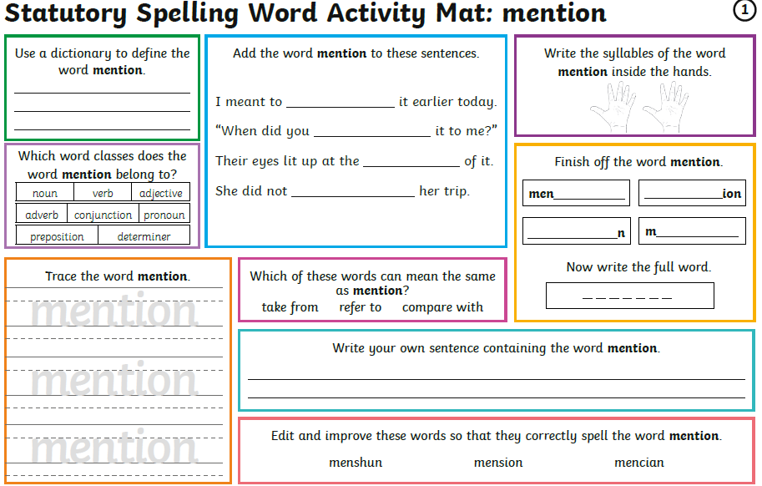

Thursday 11th June Spelling
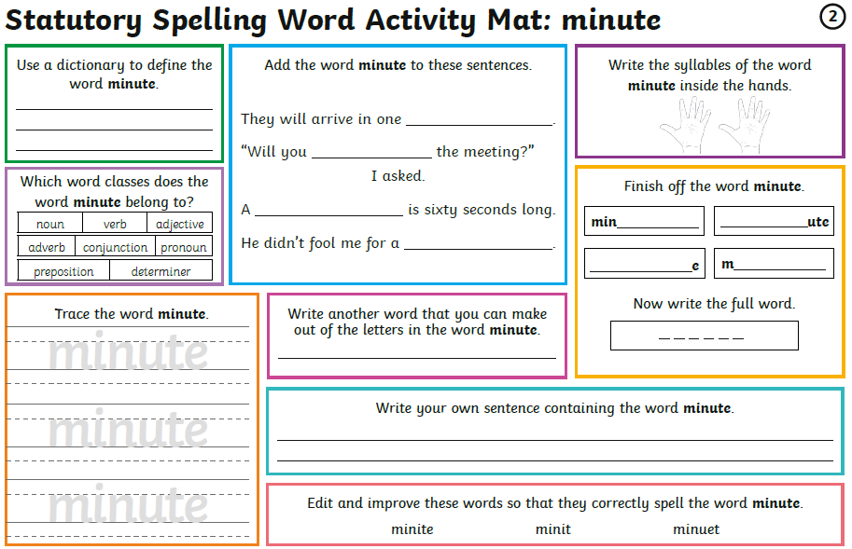

Friday 12th June Spelling
