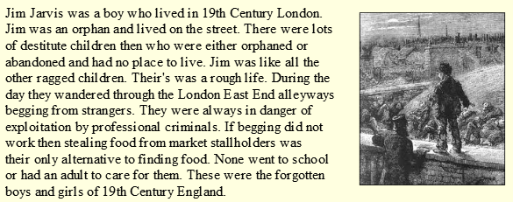
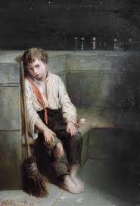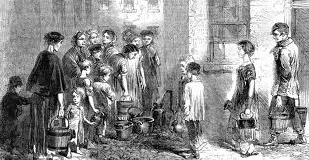
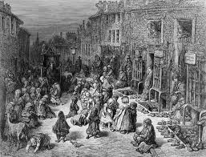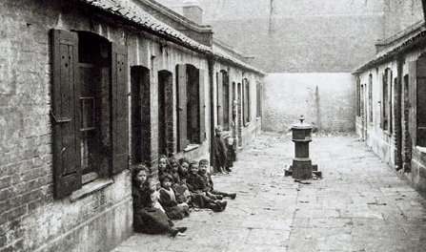

Task
Imagine you are Jim – am orphaned street child, who lived in London’s East End during Victoria times.
Use the text and the images above to infer information to write a diary entry. Use the writing template and your checklist to ensure you have included ‘diary entry’ features.

