Year 5 Home Learning (Topic) WC 15th June 2020
Dear Year 5,
I hope you are all well. This week, you will be start to revise some of the topic learning you have completed throughout the year. To start with, you will be revising your history knowledge of Anglo-Saxon and Viking kings, as well as some important key events from this period and vocabulary linked to this topic. The tasks are set on the Seneca Learning platform in your Year 5 Classroom under the heading ‘Medieval Monarchs.’

The easiest way to access your tasks is by copying and pasting the link below in your browser. This will take you straight to your assigned tasks for the week.

https://app.senecalearning.com/dashboard/join-class/ylngdrrzos

Your screen will look like this:

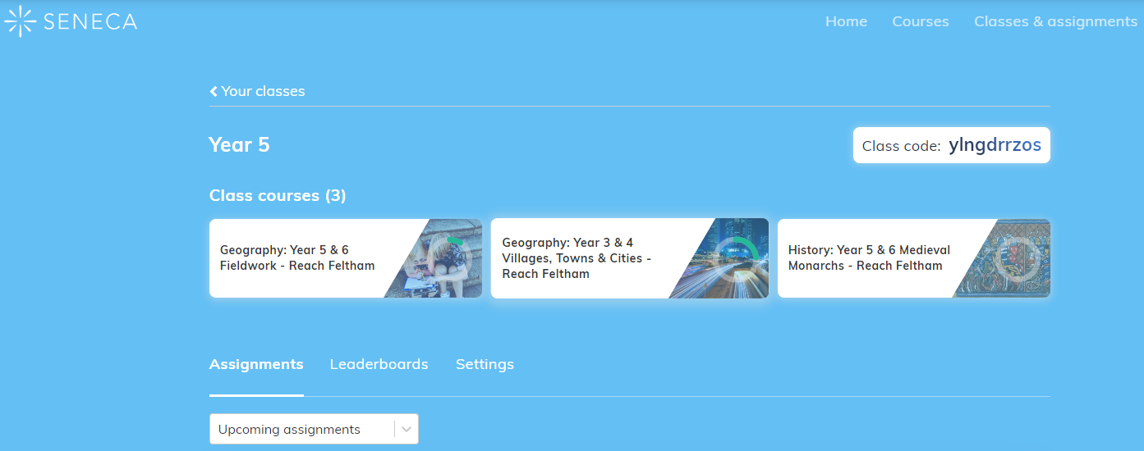
Just click on the ‘Medieval Monarchs’ section and it will take you to the screen with your allocated work.
On the left hand side, click on the arrow next to 1 Medieval Monarchs to access the activities on the drop-down menu.
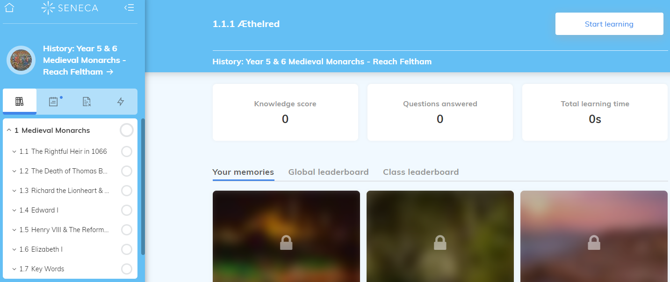
On the left hand side, click on the arrow next to 1 Medieval Monarchs to access the activities on the drop-down menu.

Alternatively, you can follow these instructions:
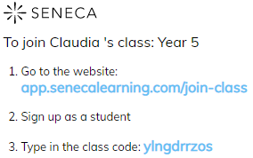
There are several tasks set for the week. Split these into junks and complete as many as you can. (If you complete all tasks, this should take around 2 hours in total.)

If you have any questions, please contact me via the Year 5 e-mail: y5@williamdavis.org.uk
Have a great week! Claudia

