Dear Y6 parents/carers

If you need any additional home learning for your child or they would like alternative maths and English lessons please use the lessons from The Oak National Academy, a new collection of high-quality lessons and online resources. Backed by the Government, it has been created in response to the coronavirus lockdown. The online classroom offers free access to great teachers, delivering video lessons, quizzes and worksheets. All of the lessons are ordered so your child can learn along a clear plan. They provide new lessons and resources each week.

1: Go to the website. https://www.thenational.academy/
2. Select ‘classroom’
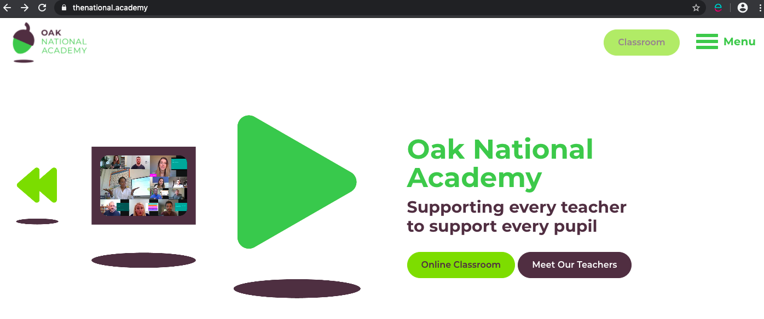

3. Select ‘Schedule’
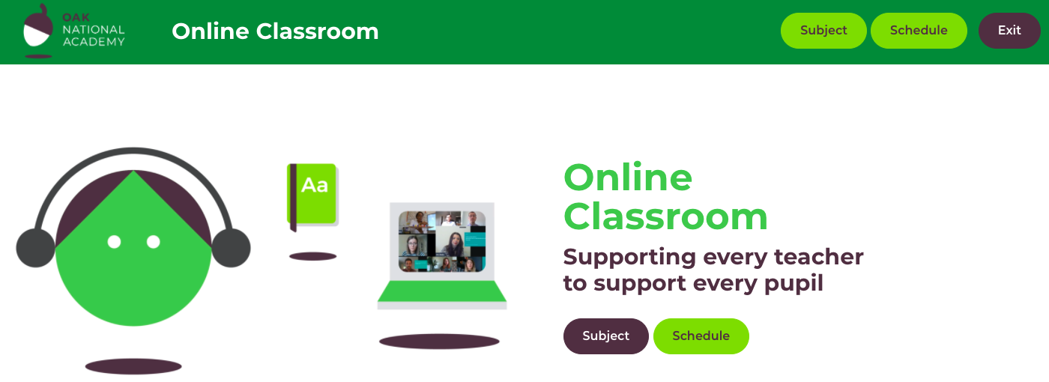

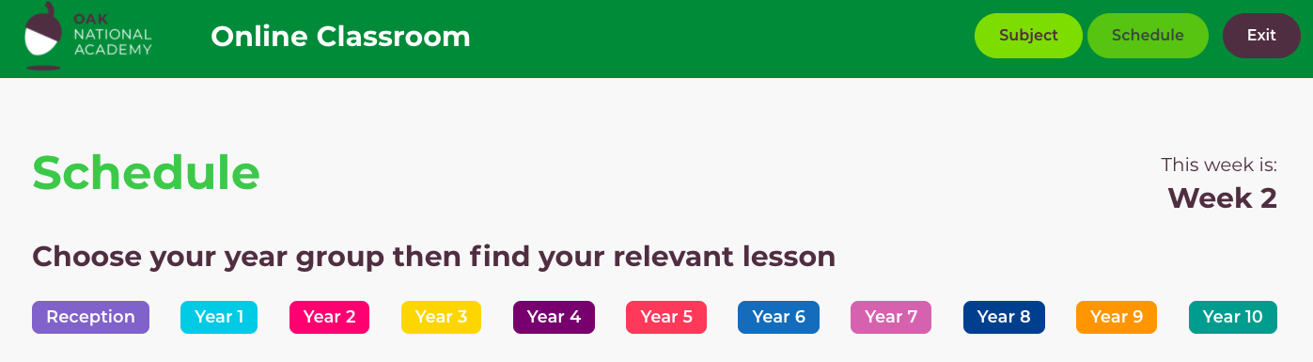
4. Choose your year group

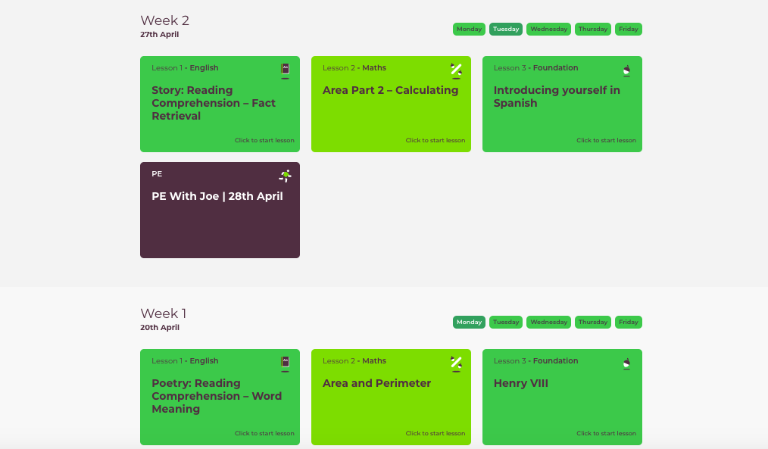
5. Check the weekly plan that your class teacher has sent you to see which week you are working on.

Choose the day of the week
Website
Our website is being redesigned. We apologise for the delay with providing up to date information. The new site should be on line next week.

Volunteer Readers
Could you regularly spare time to listen to readers? Please see Annika or Siobhan.

Select the subject and lesson

You are ready to go!
Each lesson starts with a quiz. You need to close the quiz when you are finished and then watch the lesson.

