Year 5 Home Learning Topic (Geography) WC 22nd June 2020
Dear Year 5
This week, we will continue to revise our geography skills linked to our topic of ‘My London’. You will be completing your revision on:
- Settlements
- Fieldwork (map skills)
As last week, tasks to be completed will be on the Seneca Learning platform.

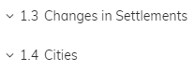

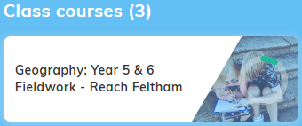
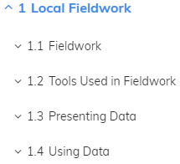

Just a reminder how to access your Seneca class:
The easiest way to access your class work is by copying/typing this link into your browser:
https://app.senecalearning.com/dashboard/join-class/ylngdrrzos
This will take you straight to your assigned tasks. Alternatively, you can follow the instructions below:
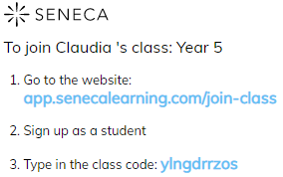
Please contact me via the Year 5 email – Y5@williamdavis.org.uk - if you have any problems.
Have a good week!
Claudia

