Comparing the Arctic and Antarctica
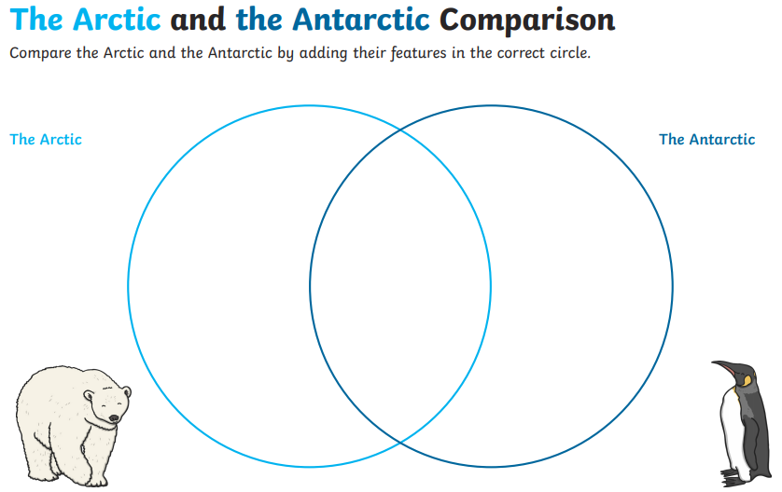

- Sort these statements on the Venn diagram

- Northern hemisphere
- Southern hemisphere
- Freezing temperatures
- A continent
- Icebergs
- Polar bears
- Whales & penguins

- Can you add your own statements?

