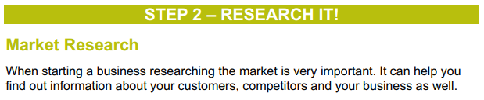

Find out what your customers might want from your product or service by doing Remote Market Research.

Asking your friends, classmates and family is a great way to help you find out important information about your business idea. You can use these questions or add your own if you would like. Please note - this survey is only to be completed at home under parent/carer supervision if necessary. You can use the telephone or email to get answers from people not in your house but only if you know the people already.

