Thursday - English Worksheet 4

We can sometimes join two sentences together, using the word and. Like this…

I have a cat. The cat loves to catch mice.

This can become…
I have a cat and the cat loves to catch mice.

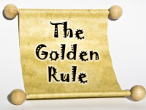
The golden rule is that we can’t join lots of sentences together! Only use 1 and.

This is not a good sentence…

I have a cat and the cat loves to catch mice and the cat is scared of dogs and the cat likes to eat meat and the cat is so fluffy.

Uh oh! This sentence is too long. It needs to be broken down into smaller sentences.

Have a go at joining these sentences together, using and.

- It is a beautiful day. I am going to the park.

- The dog barked. He chased the postman.

Now, look at your writing from yesterday. Are there any sentences you could join together, using and? Or have you used too many ands and you need to make some sentences shorter?

