Wednesday - English Worksheet 3

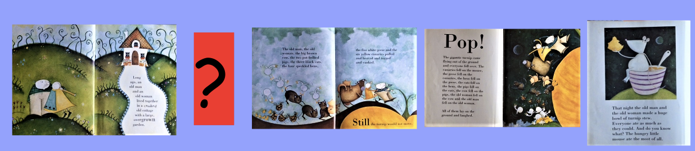

You have now drawn a picture for the missing part of the story.

Now tell me what is happening in your picture. Pretend you are the author (writer) of the book and you are writing what happens in this part of the story.

Don’t forget…
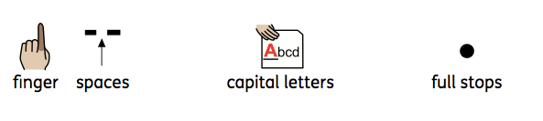
Challenge: Can you use some oomph words (adjectives)?

