Tuesday - English Worksheet 2

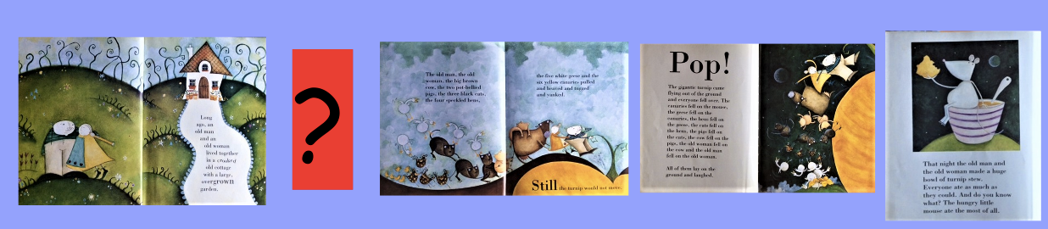

Here the pictures have been put in the right order of what happens in the story. But there is a missing part! Which part of the story should go where the red question mark is?

Draw the missing part of the story. There is more than one right answer.

